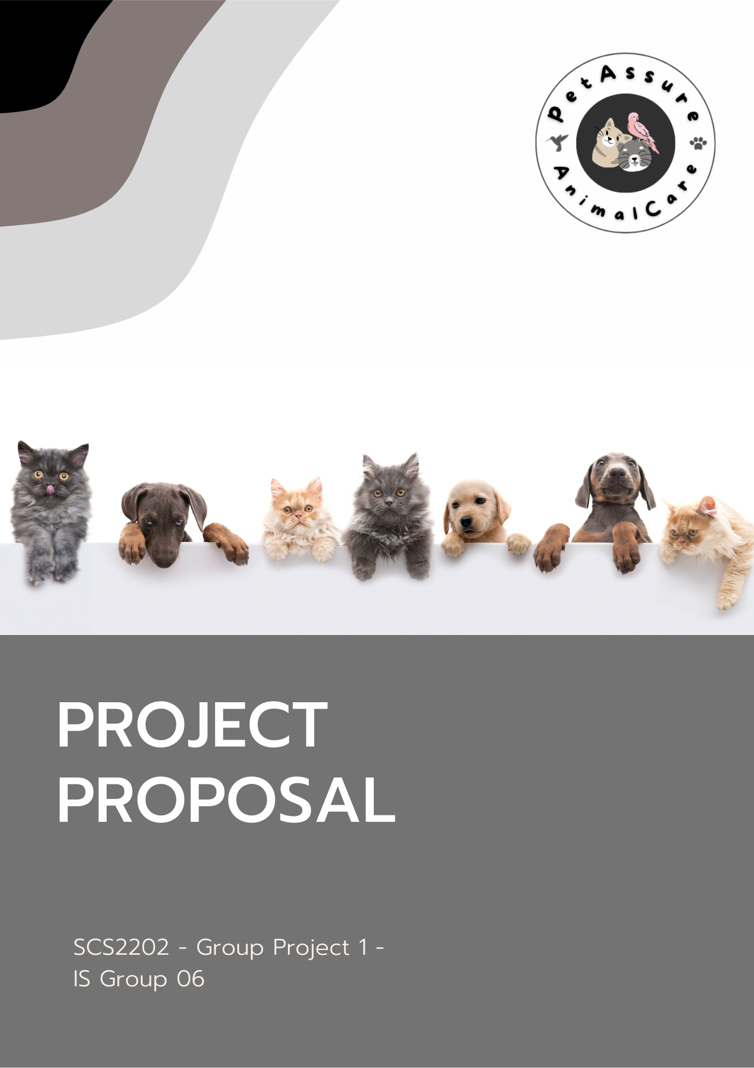

PROJECT REPORT

SCS – Group Project-

IS Group 06

Project Title : PetAssure

Group No: IS 06

2nd Year Group Project

University of Colombo School of Computing

* Supervisor : Ms. Jayathma Chathurangani
* Co-Supervisor: Ms.Lakshika Gamage

|  |  |  |
| --- | --- | --- |
| **Student Name** | **Index Number** | **Signature** |
| M.Sangeerthan | 20020937 |  |
| T.N.Wickramasinghe | 20021161 |  |
| E.M.Ishini Ekanayake | 20020341 |  |
| R.S.P.N. Krishnajina | 20020589 |  |

### 

# Use Case Diagram

### 

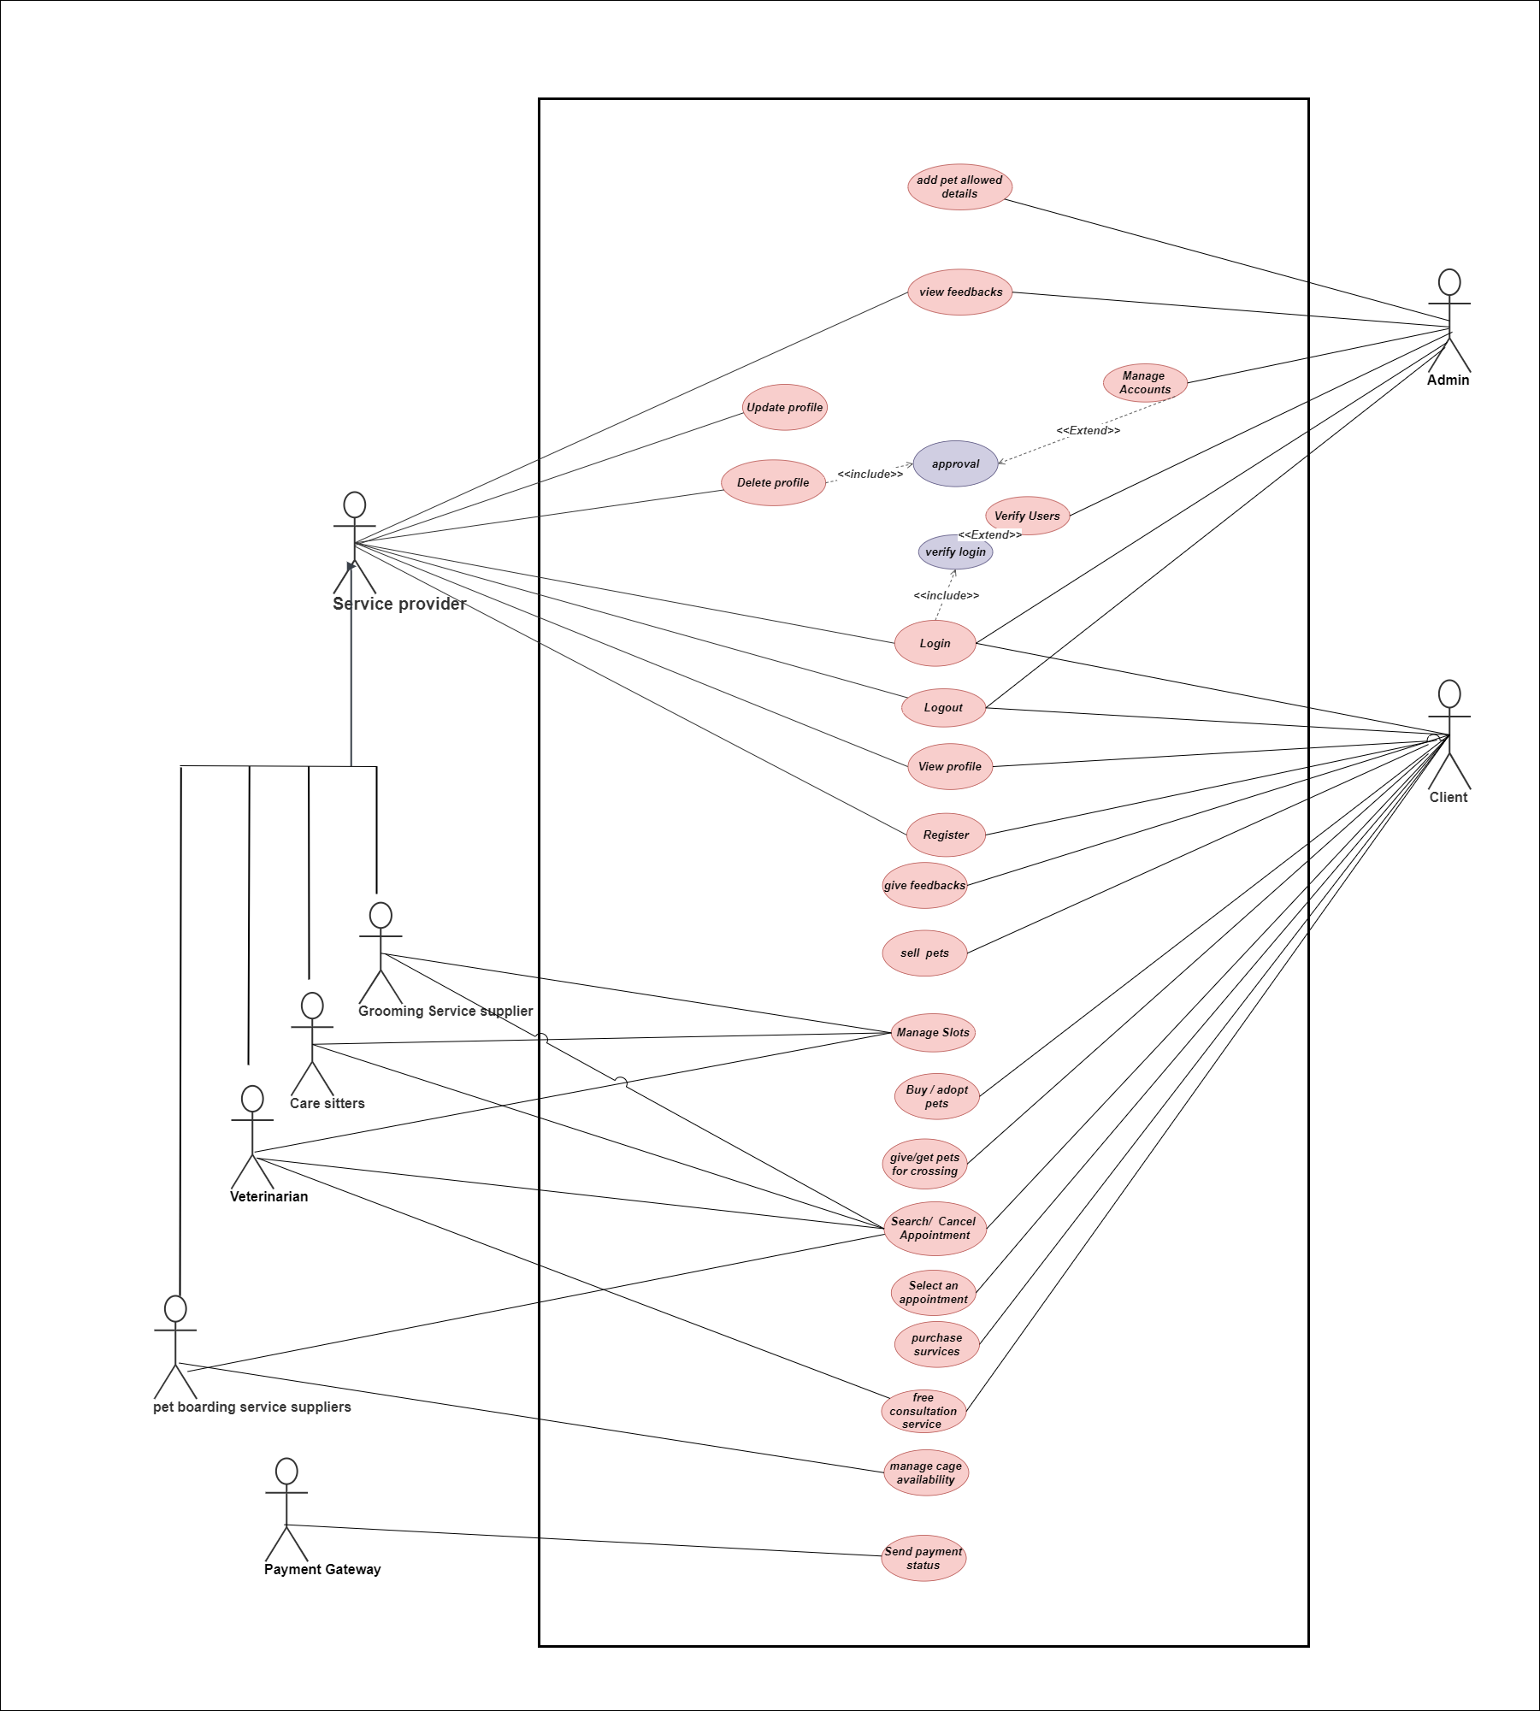

# Use Case Narratives

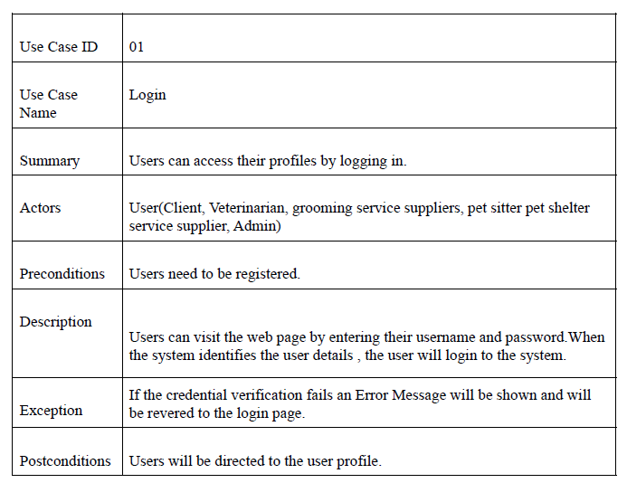

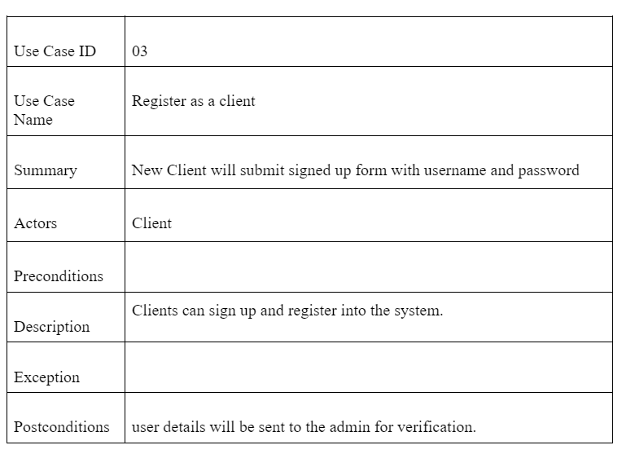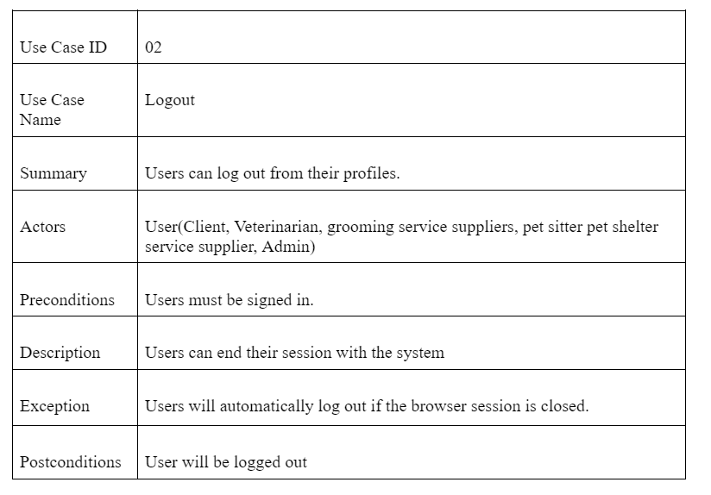

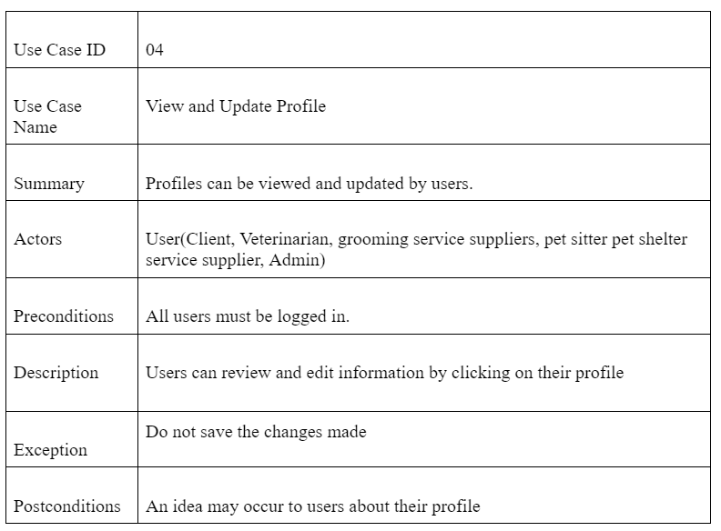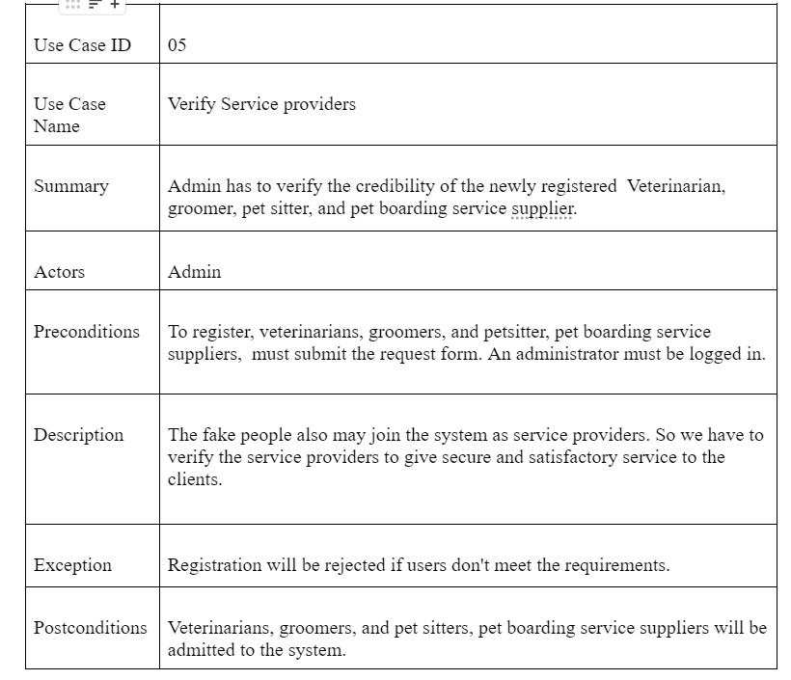

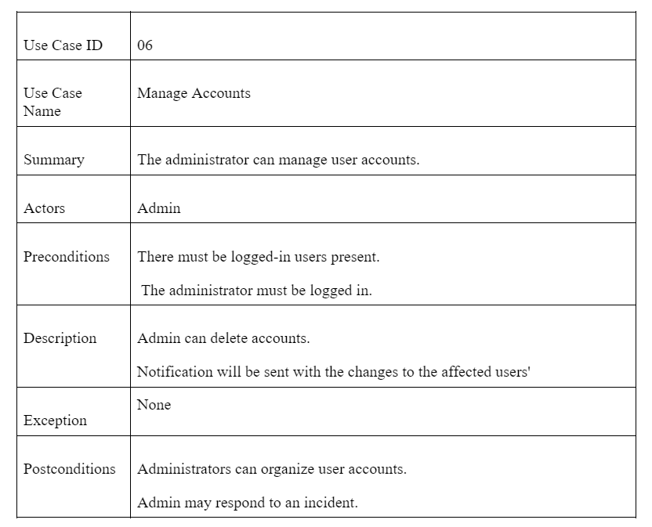

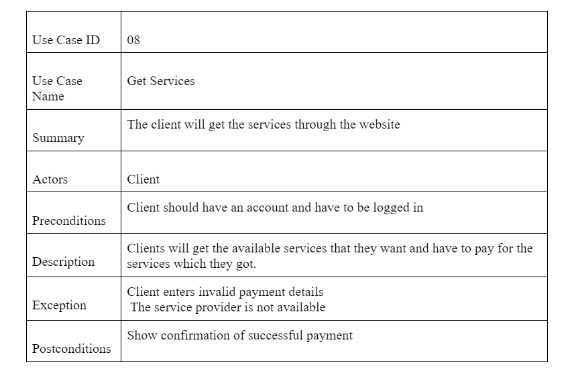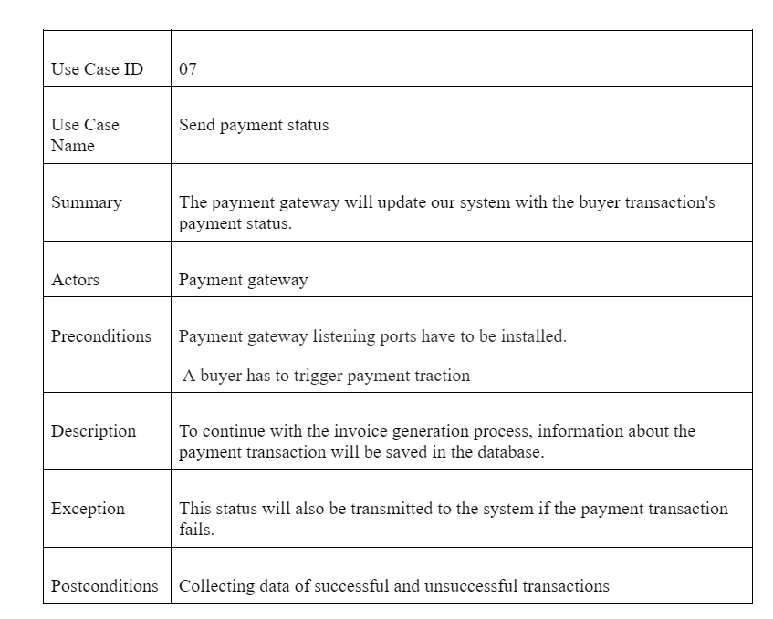

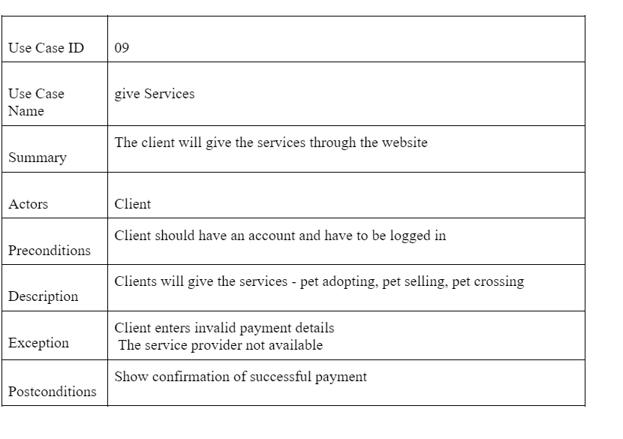

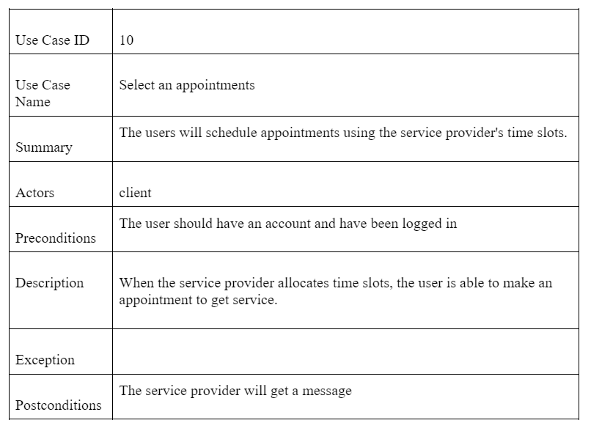

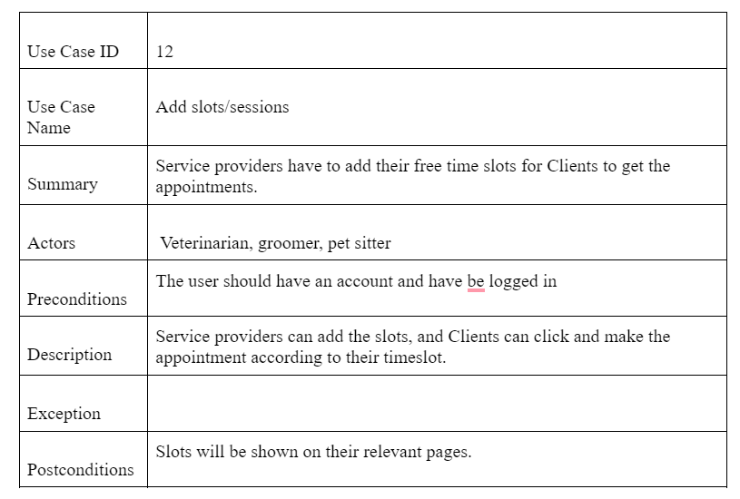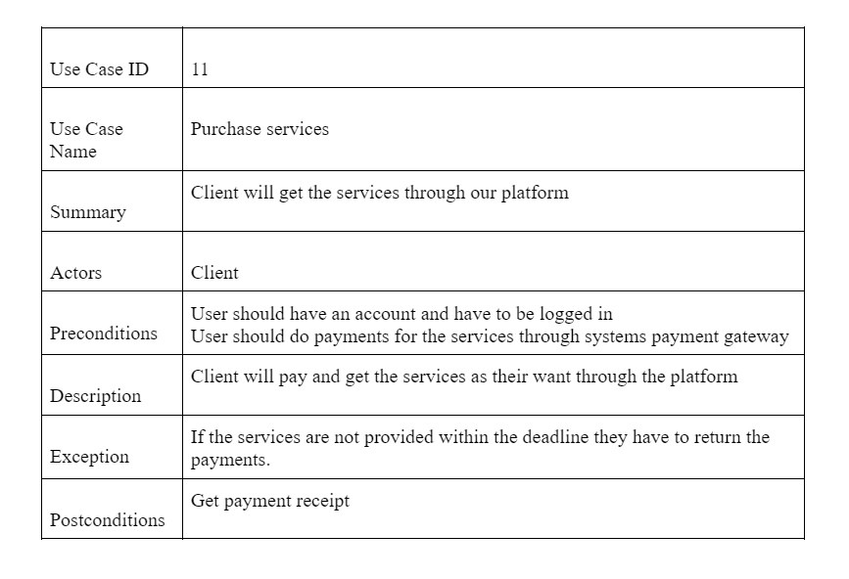

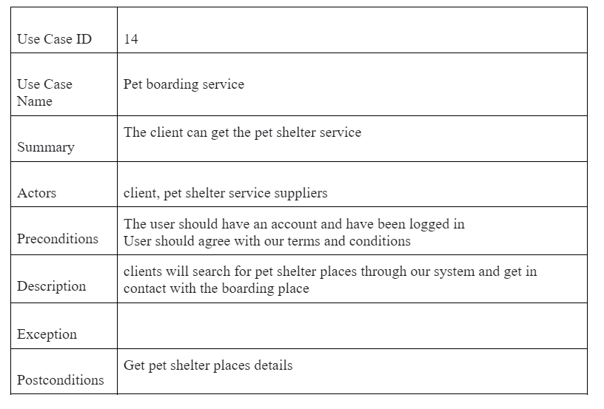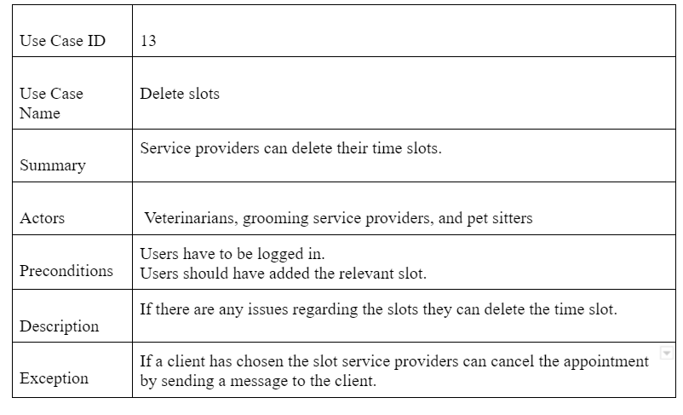

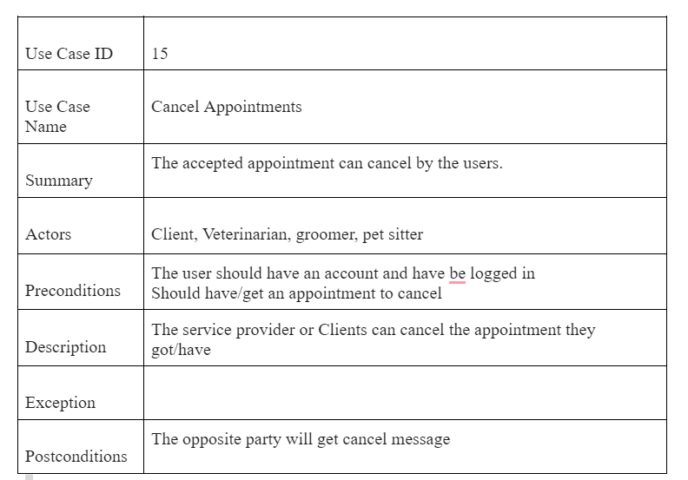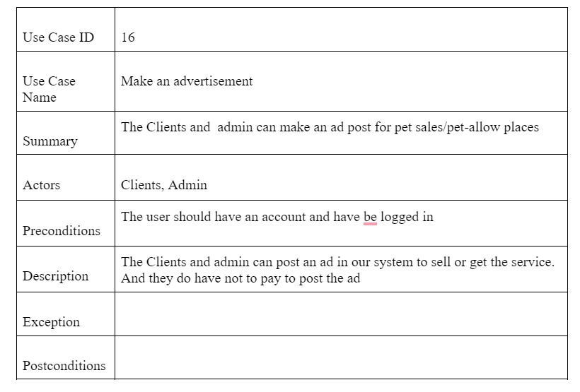

# Class Diagram

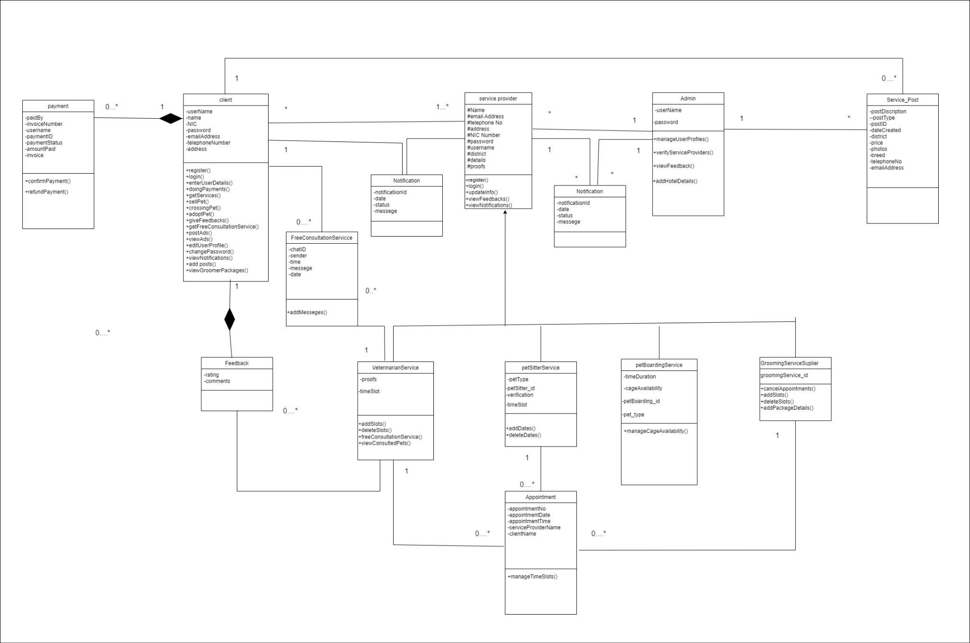

# 

# Entity Relationship Diagram

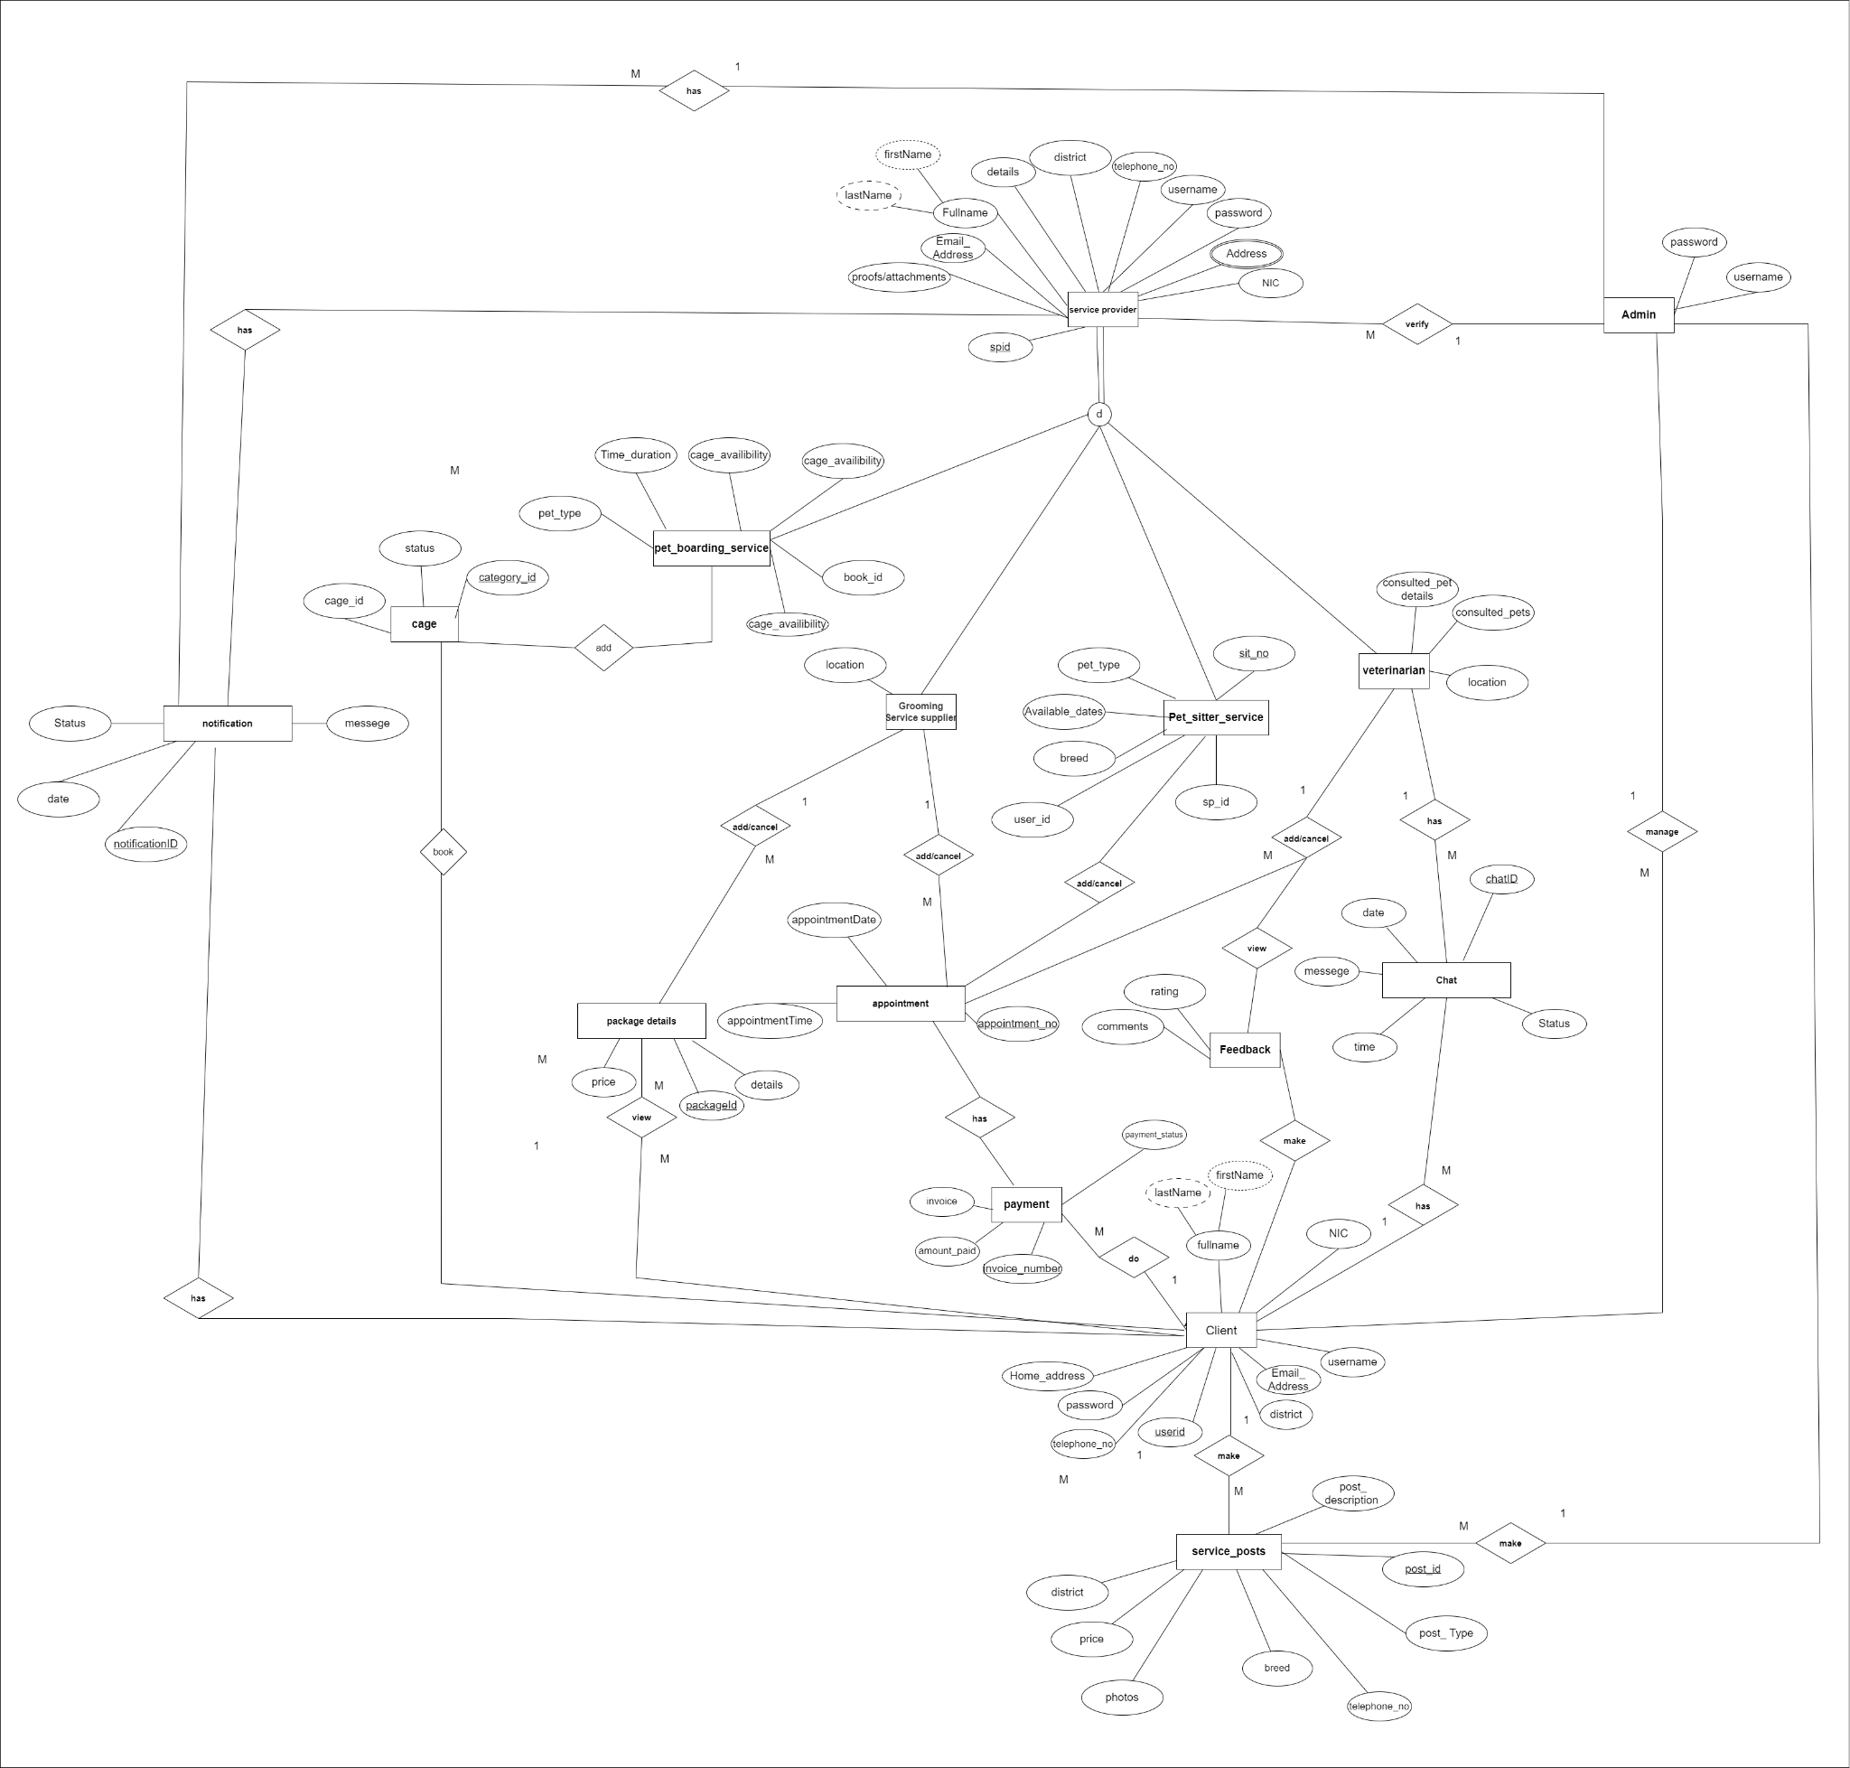

# Sequence Diagrams

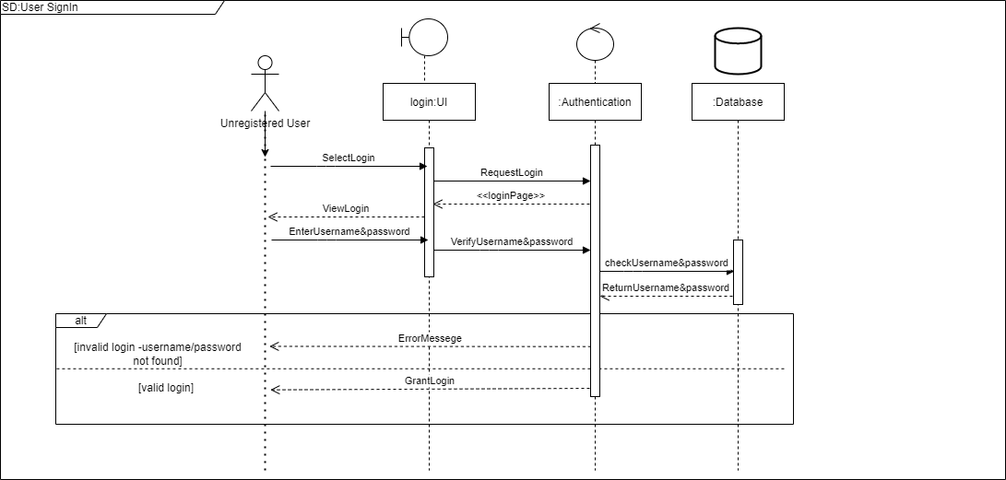

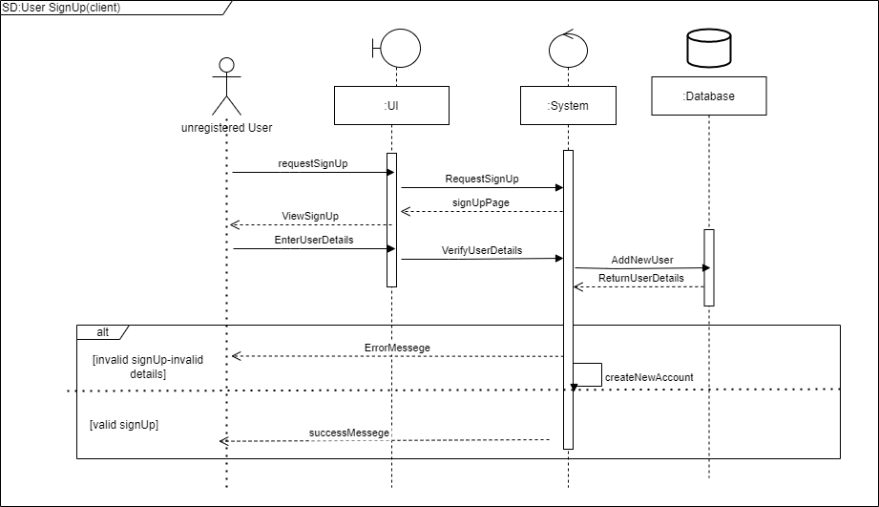

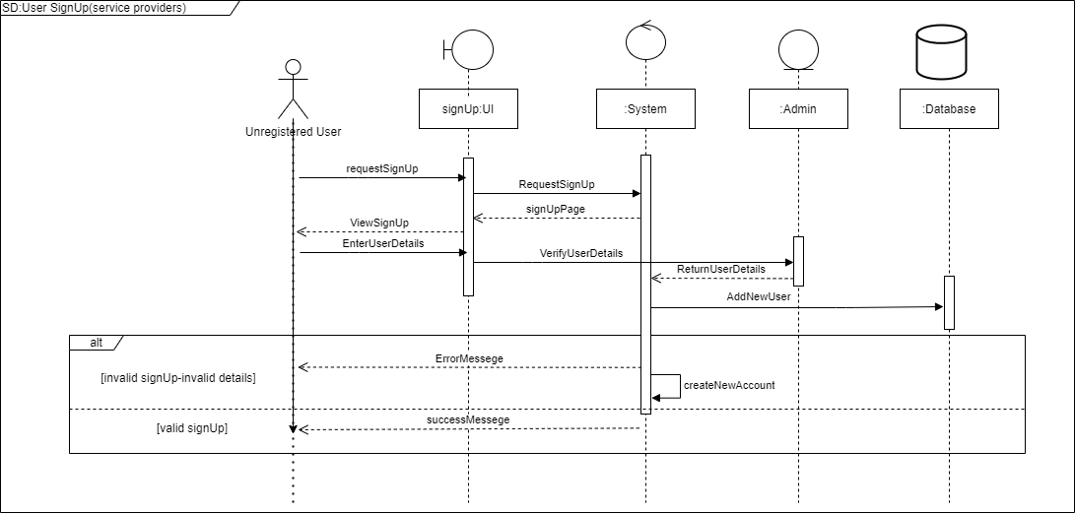

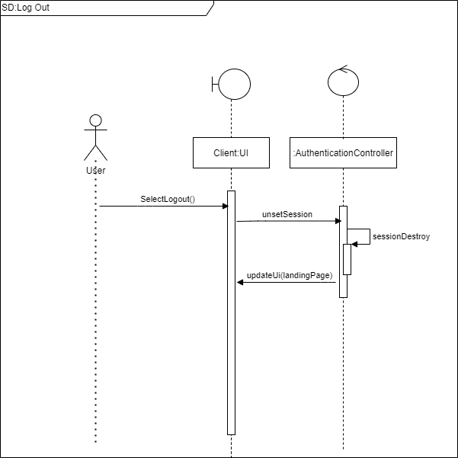

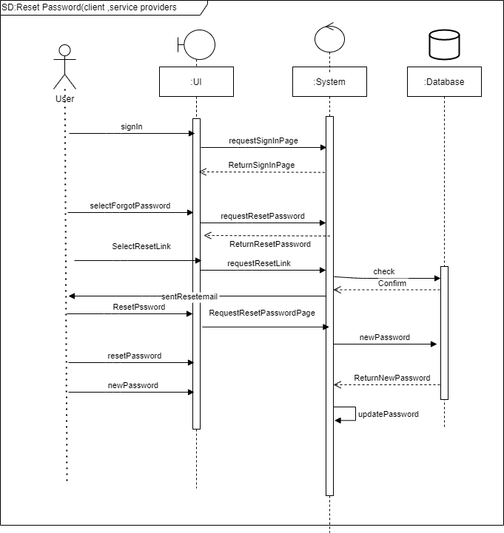

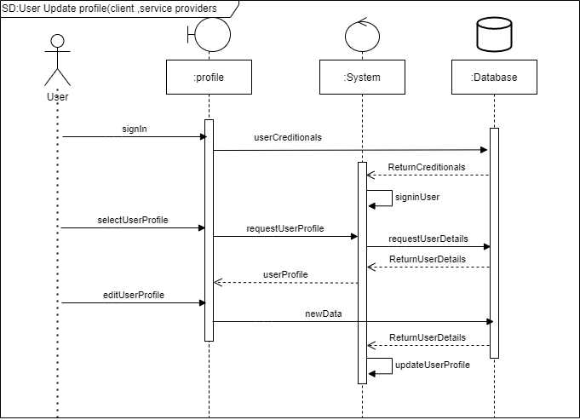

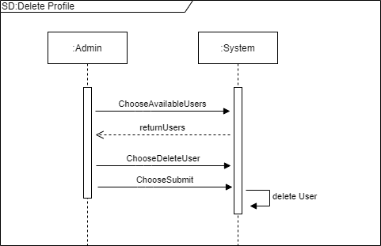

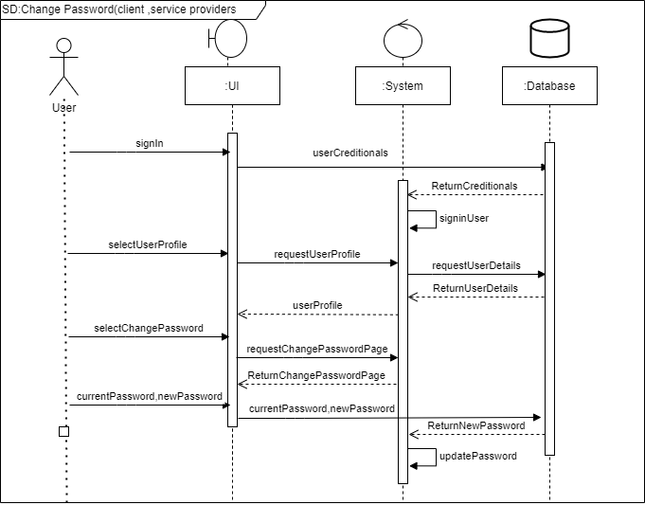

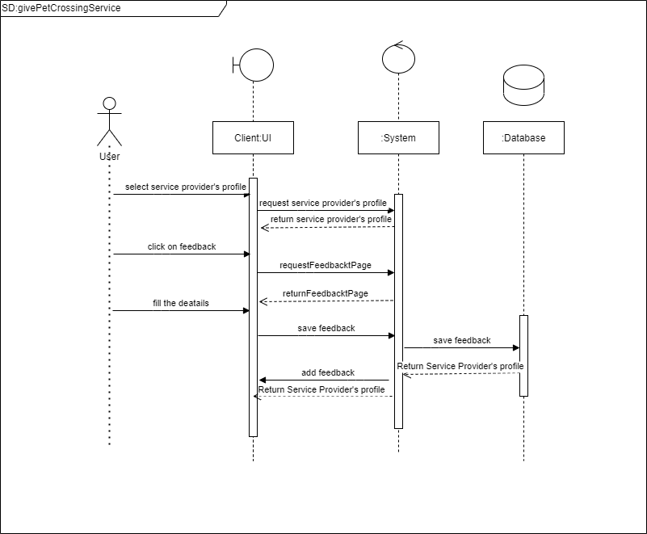

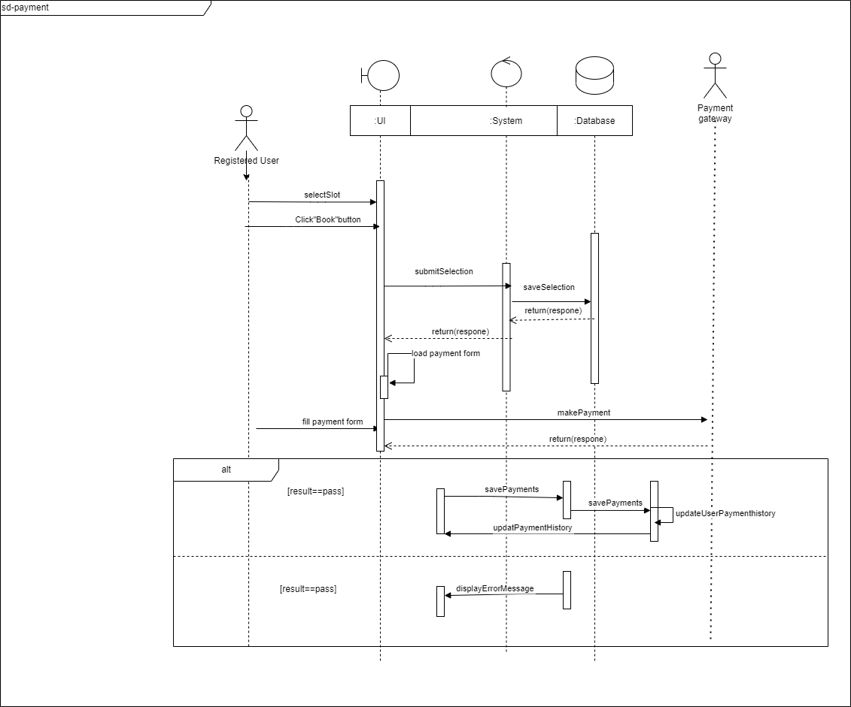

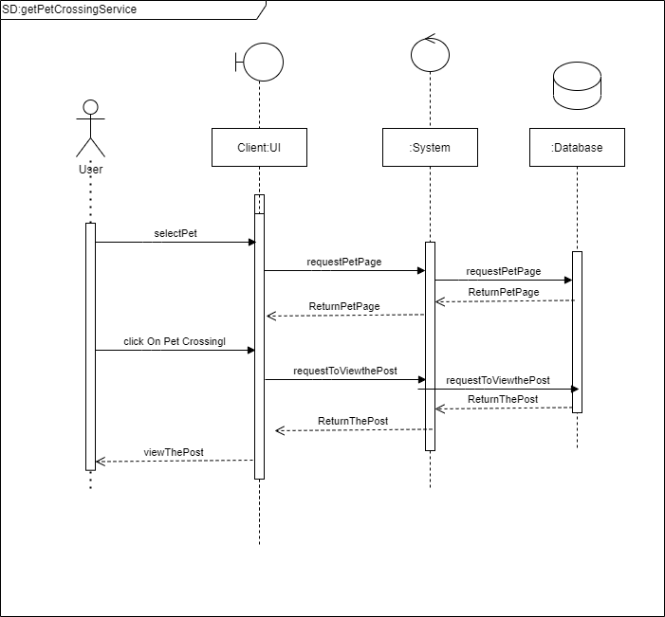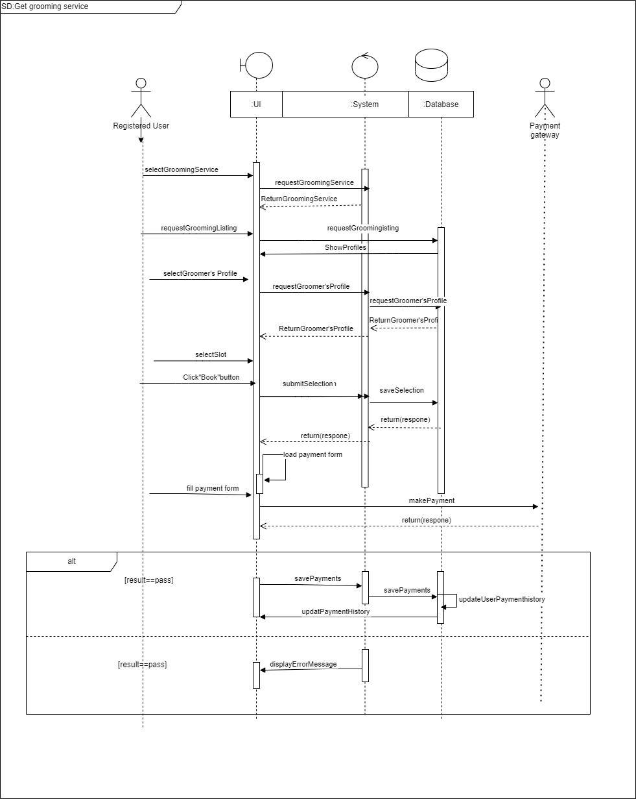

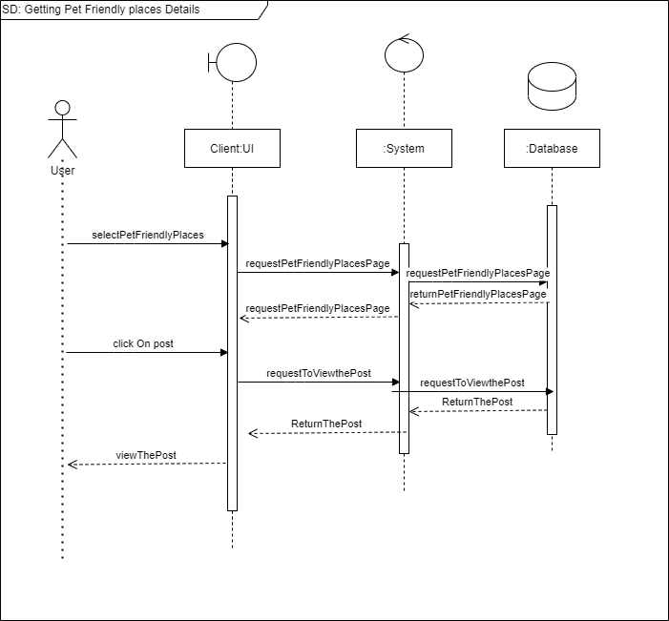

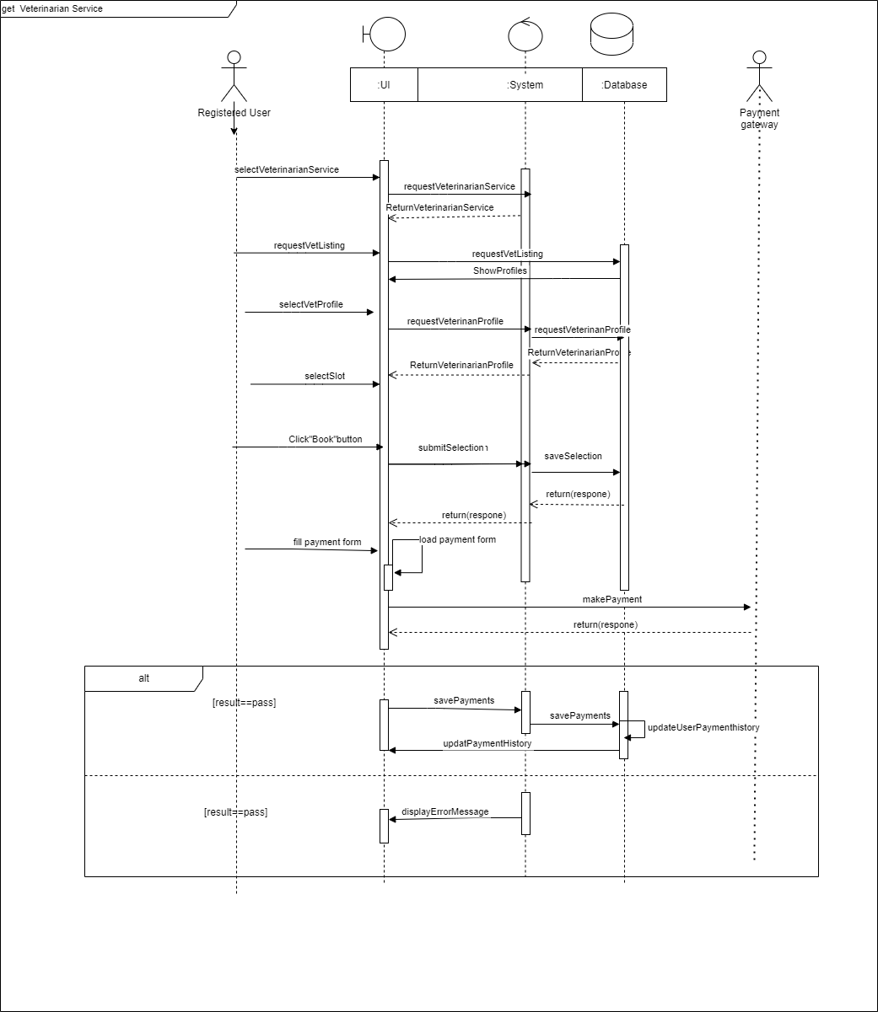

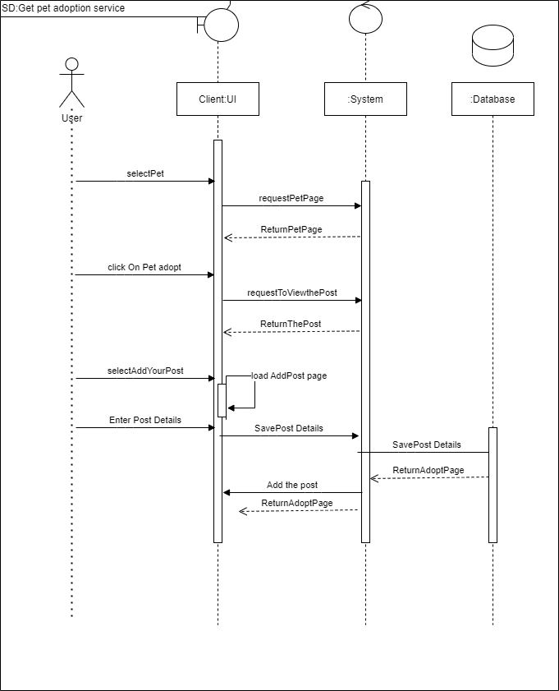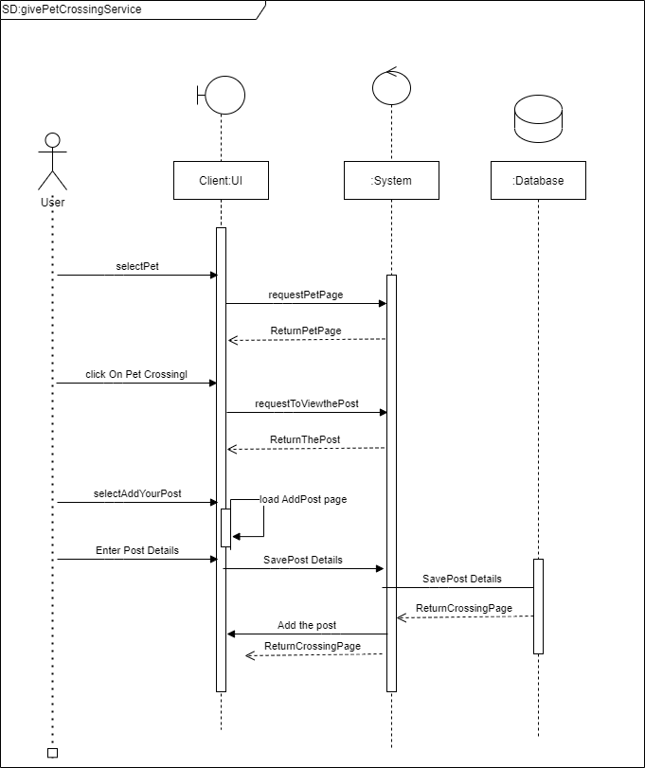

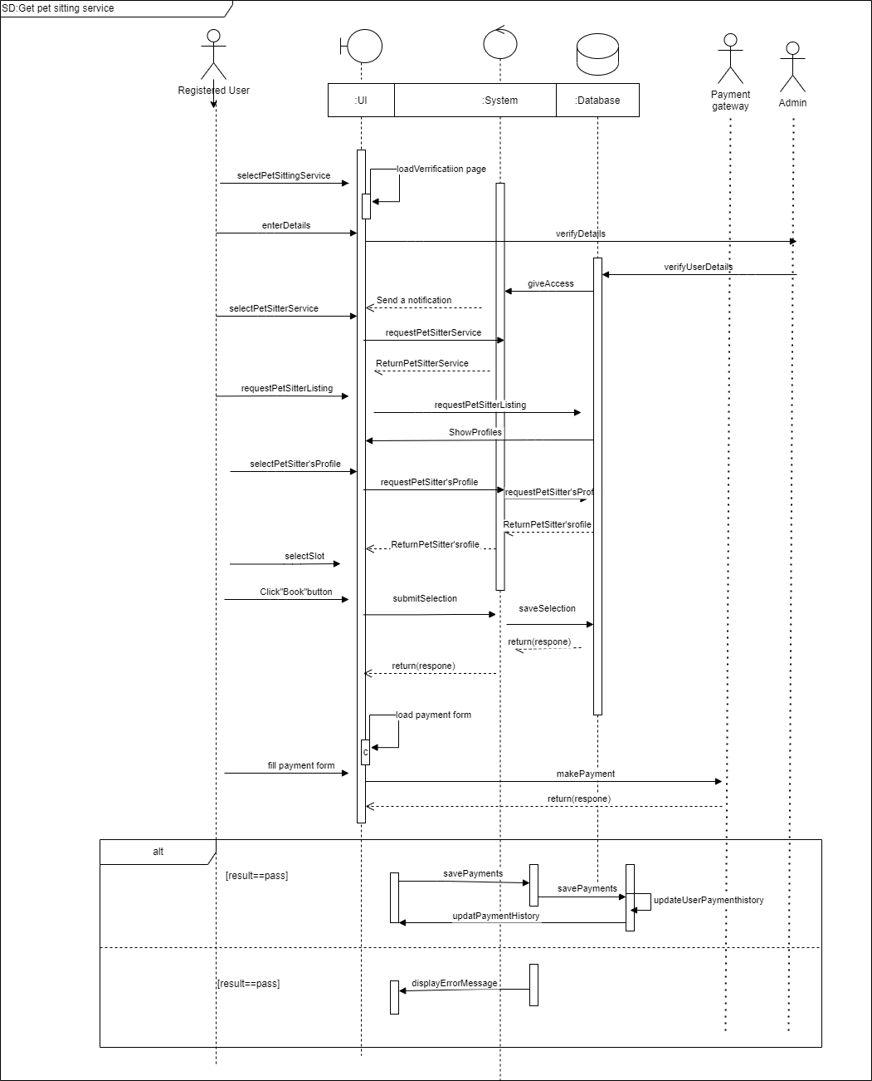

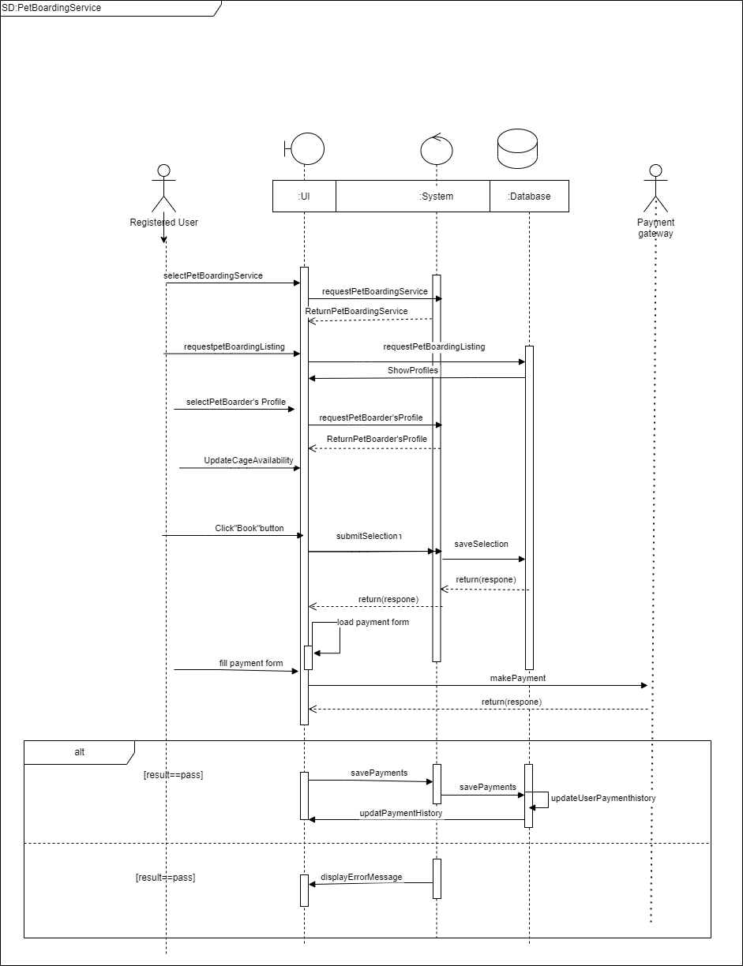

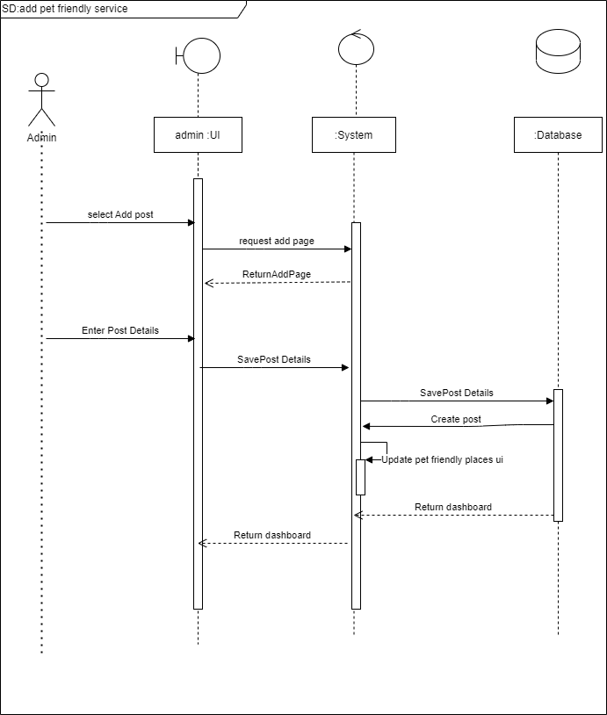

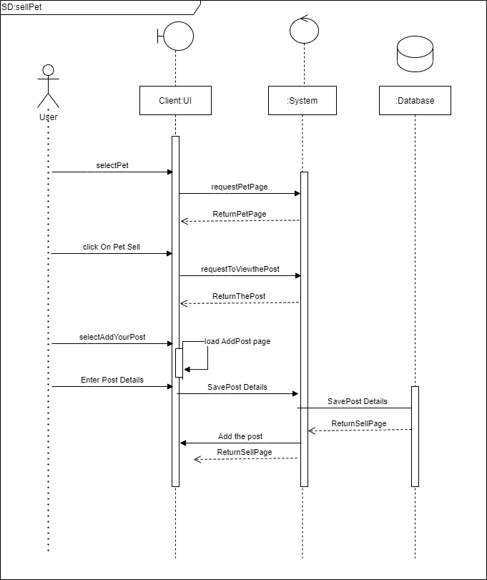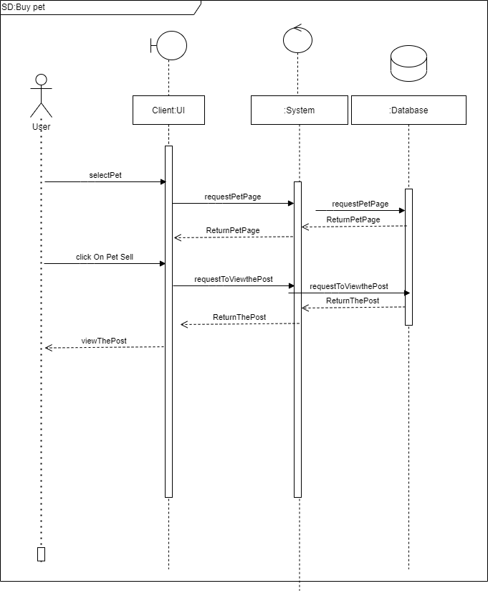

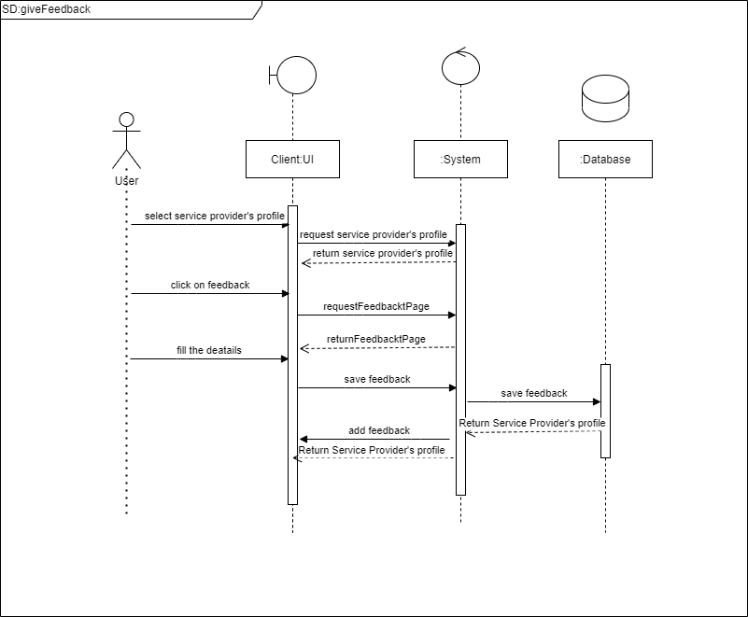

# State Transition Diagrams

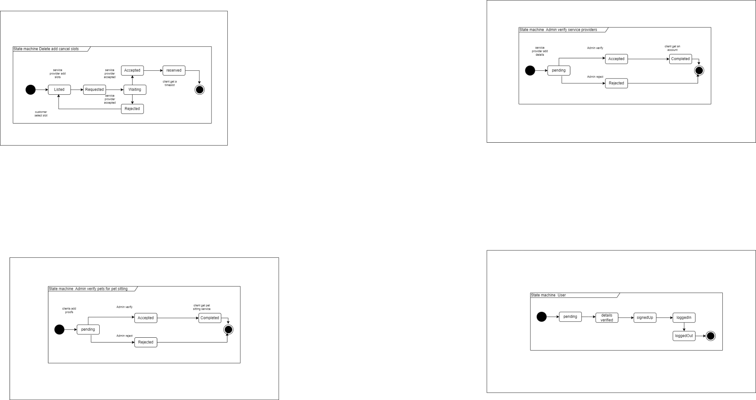

# Activity Diagrams

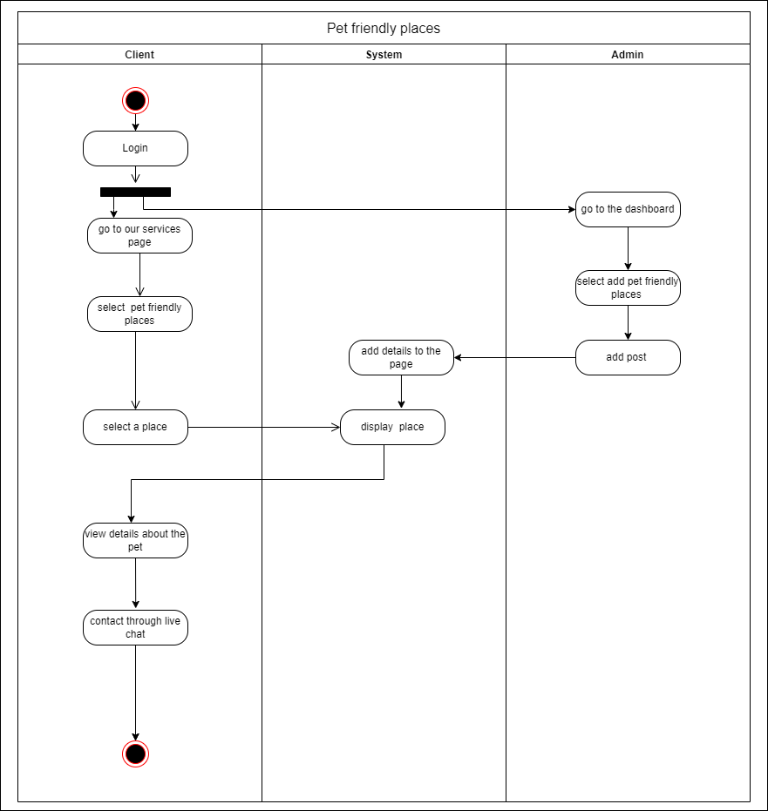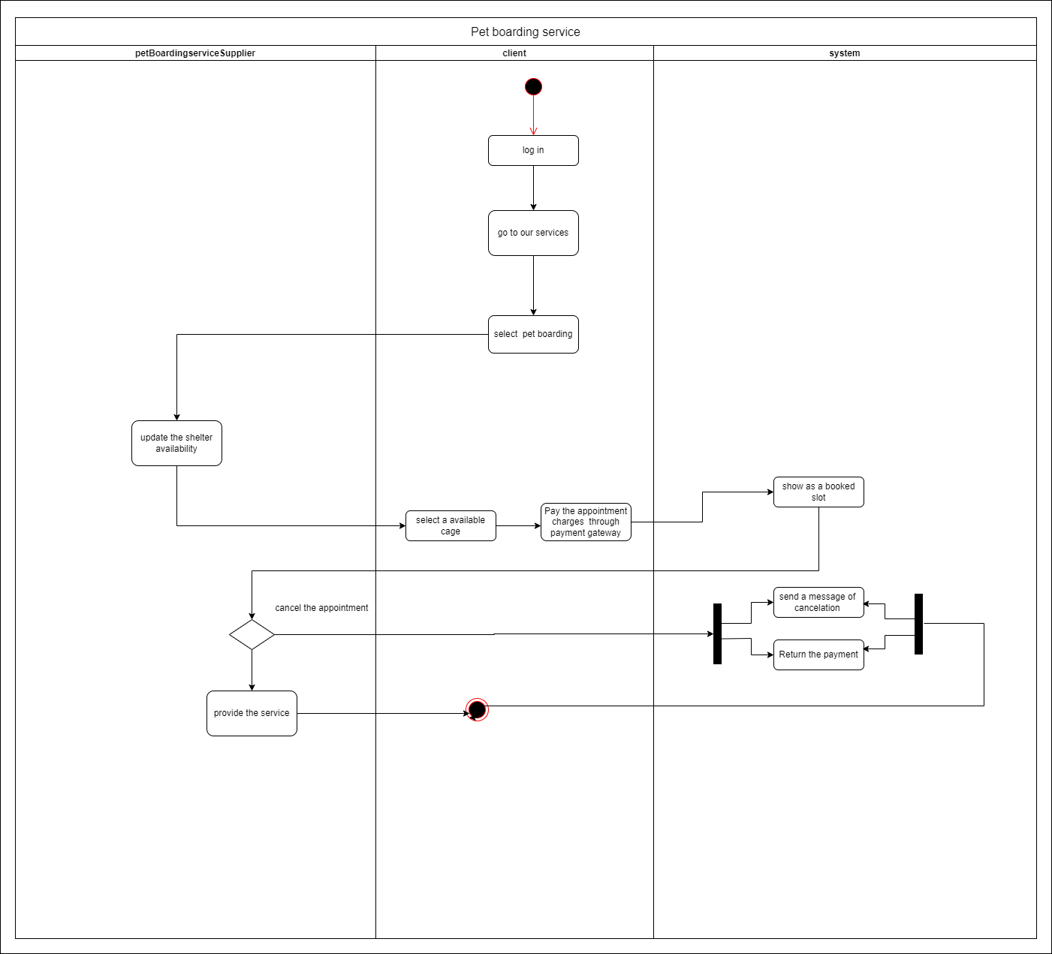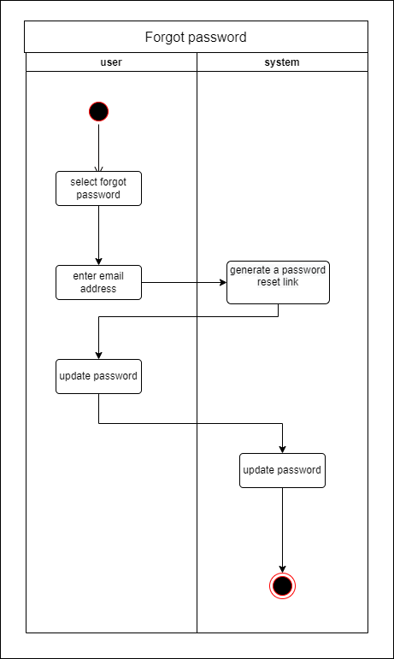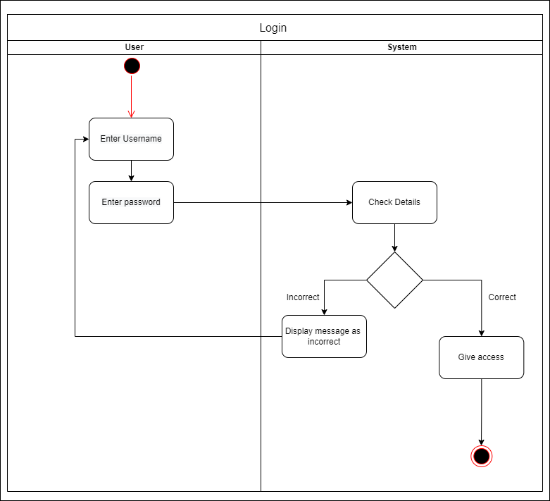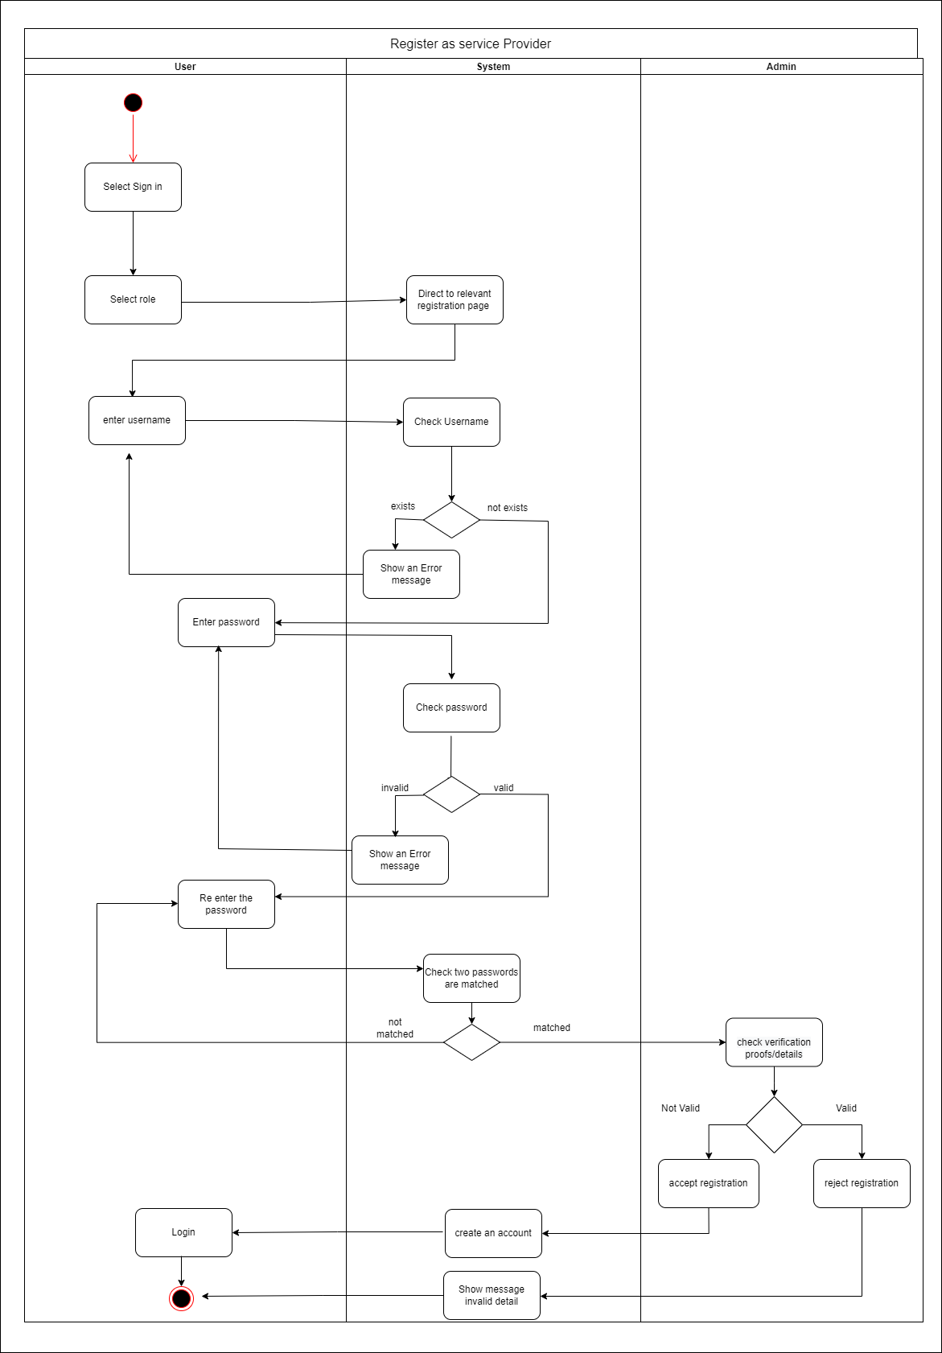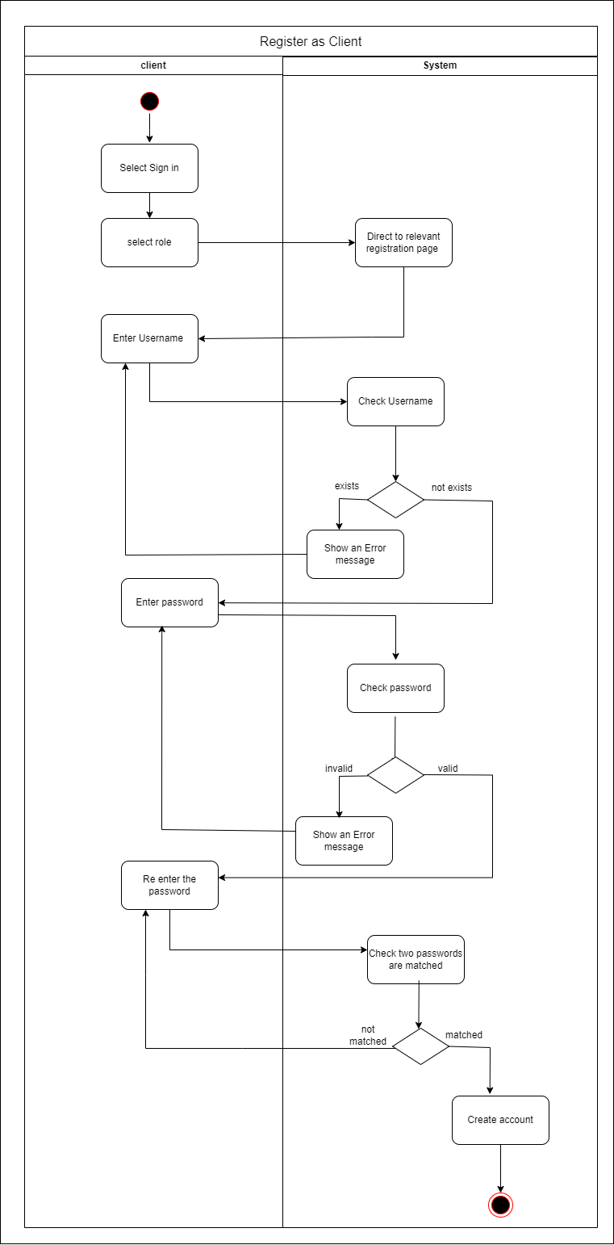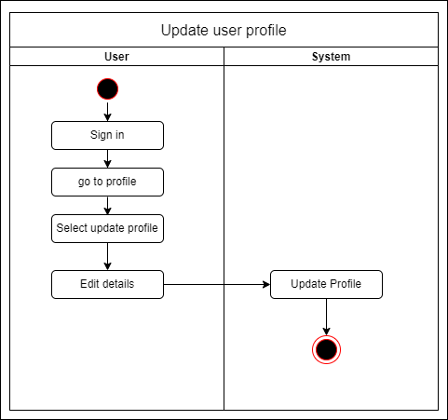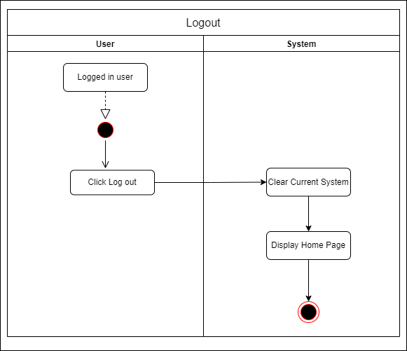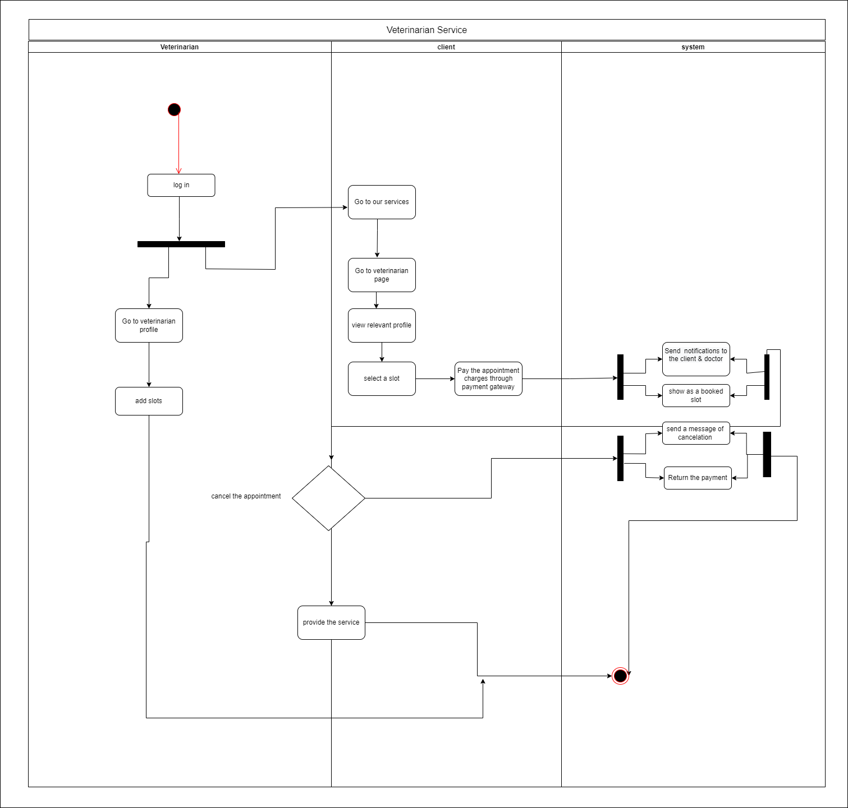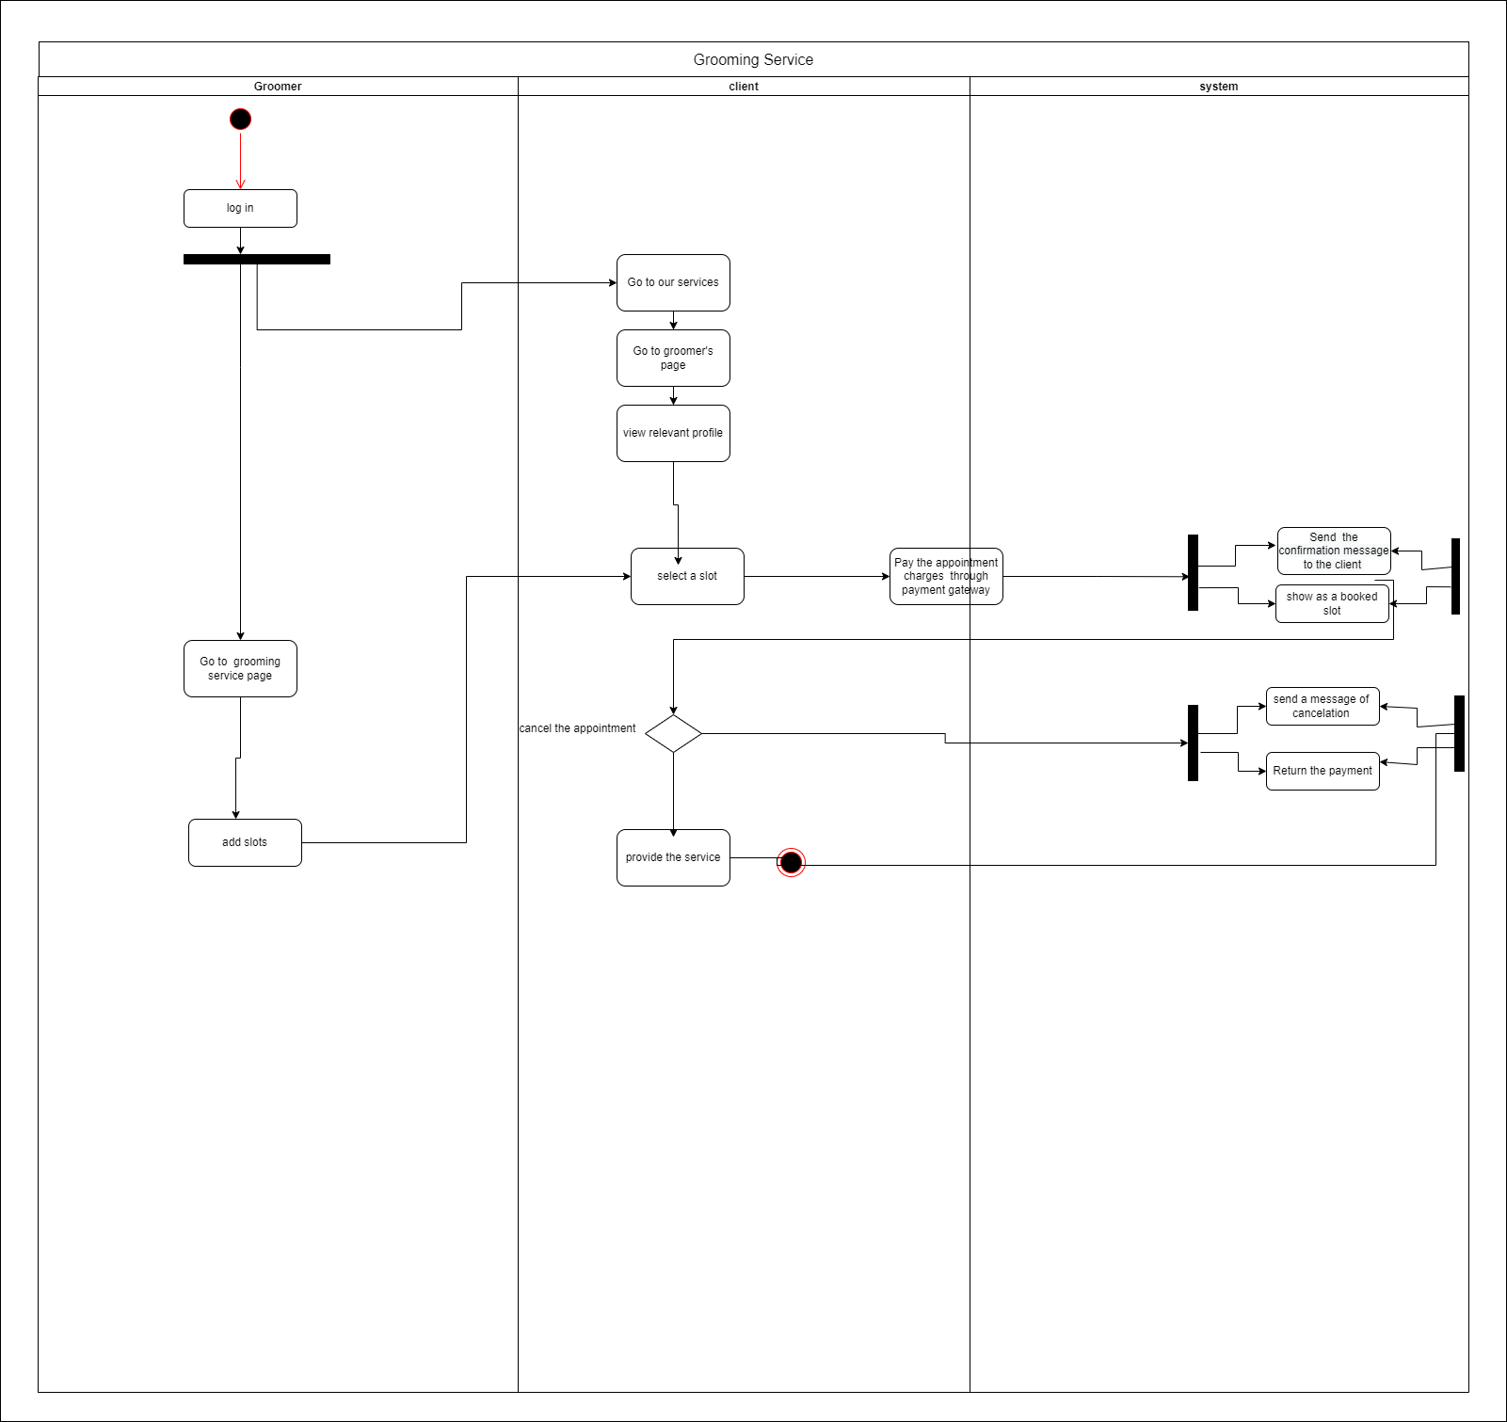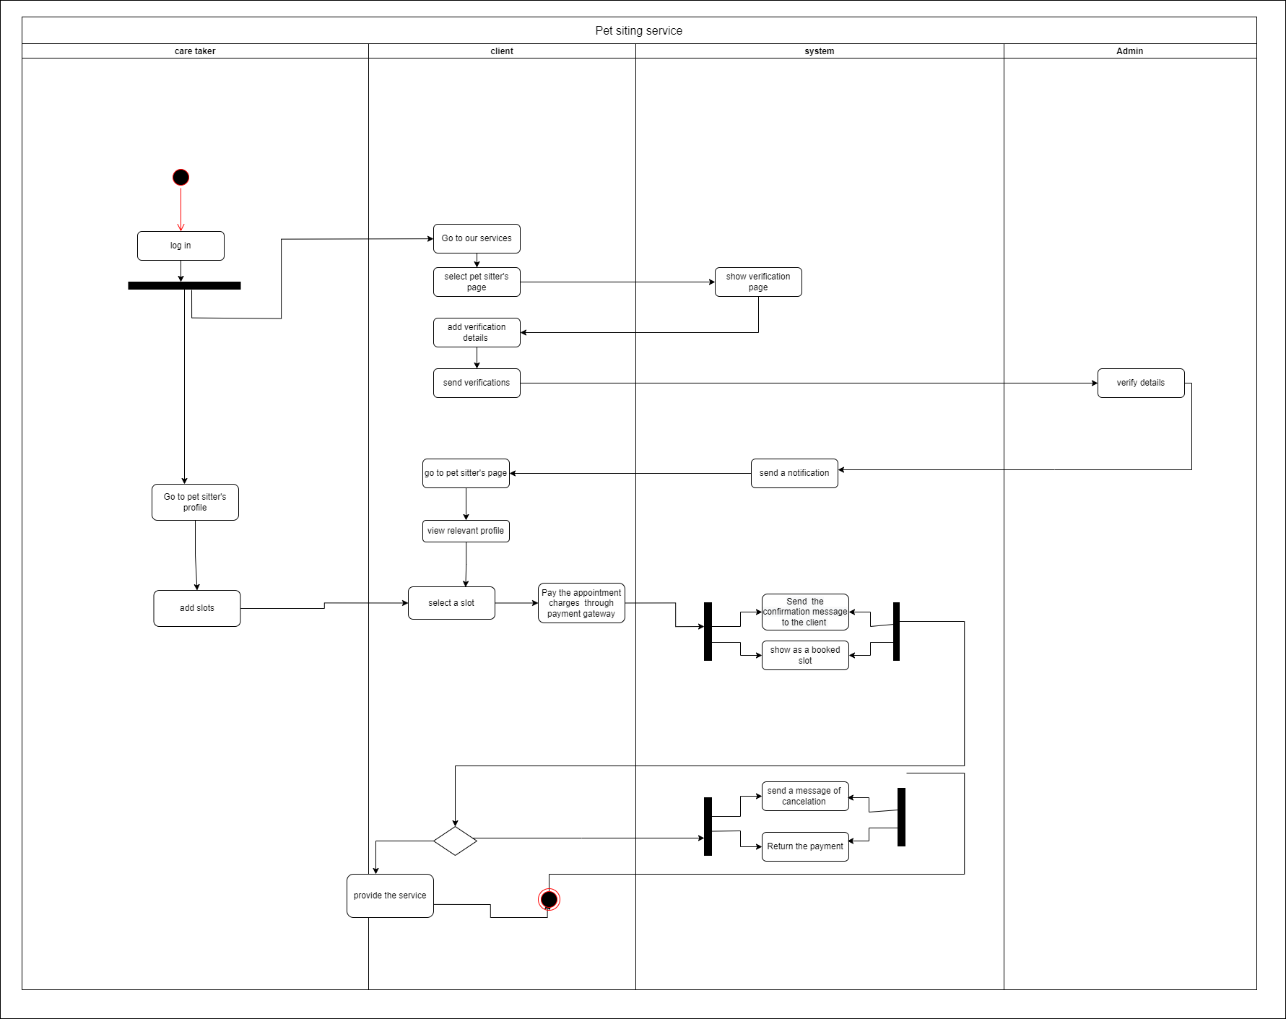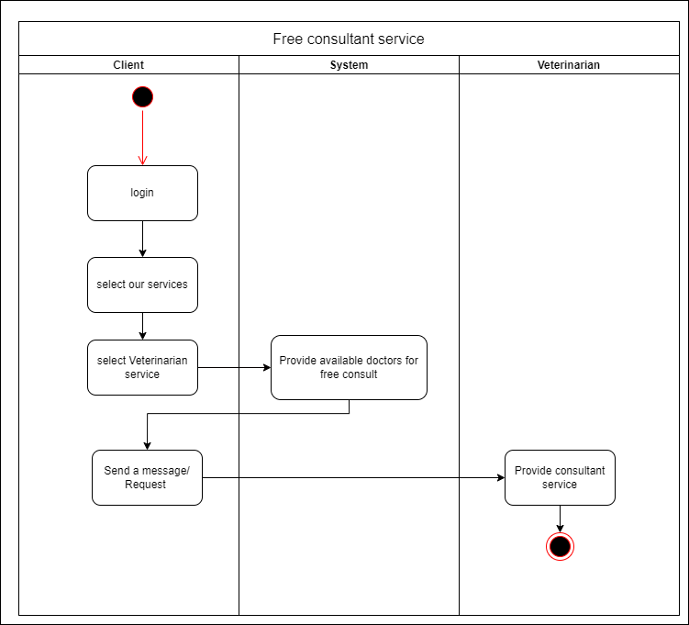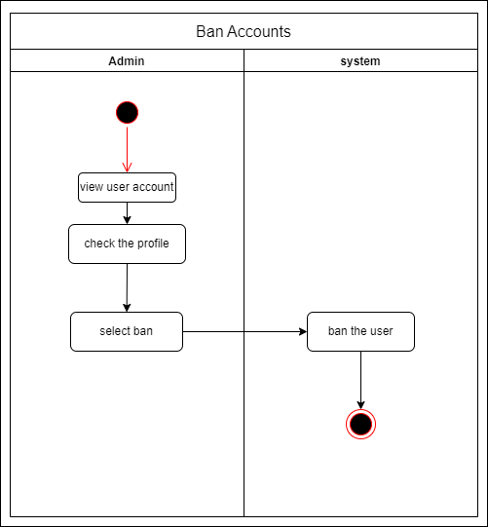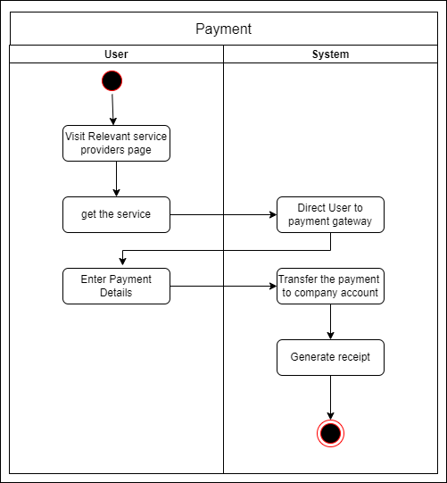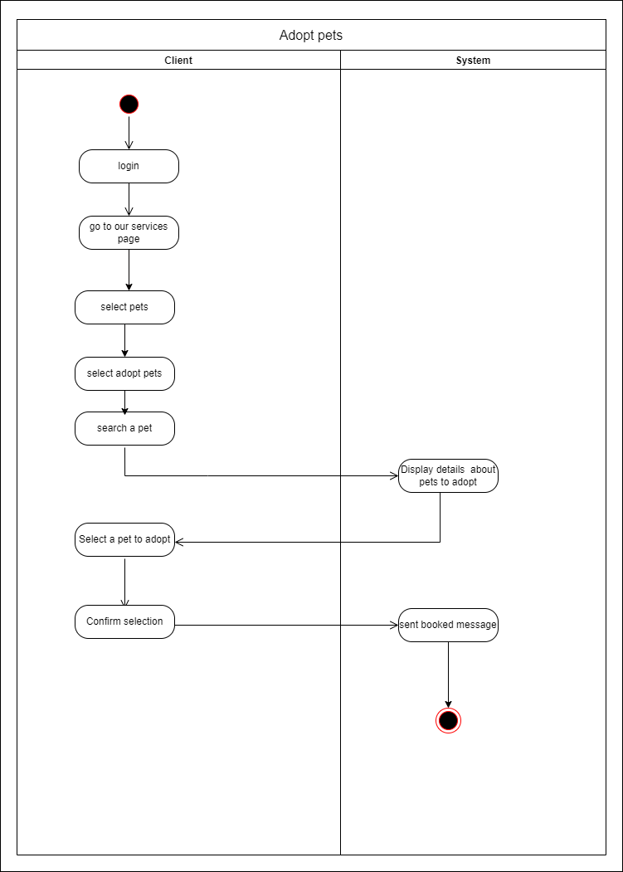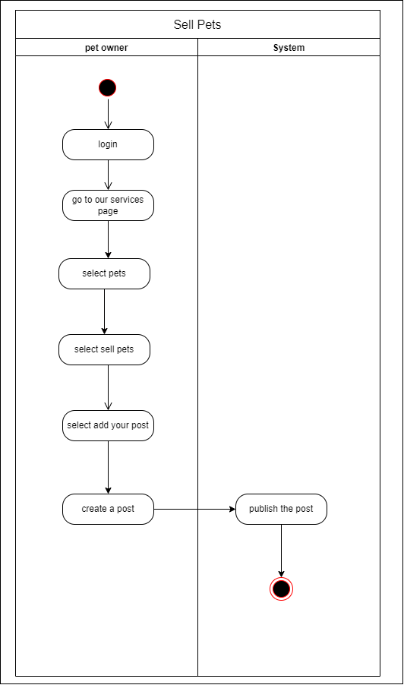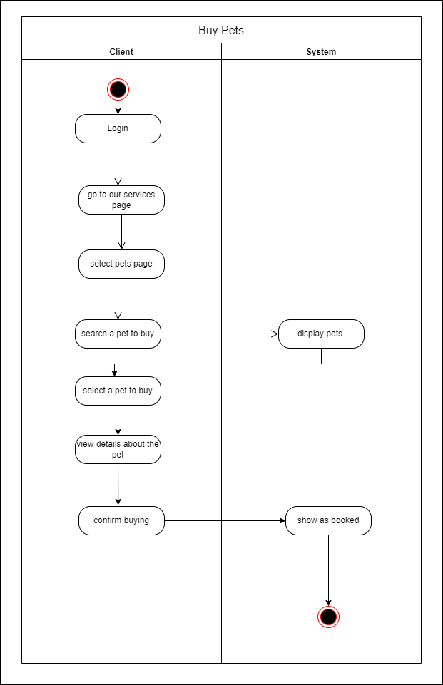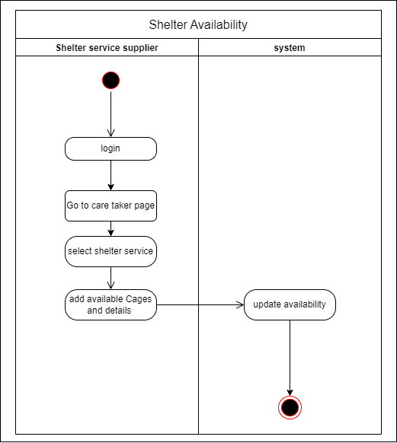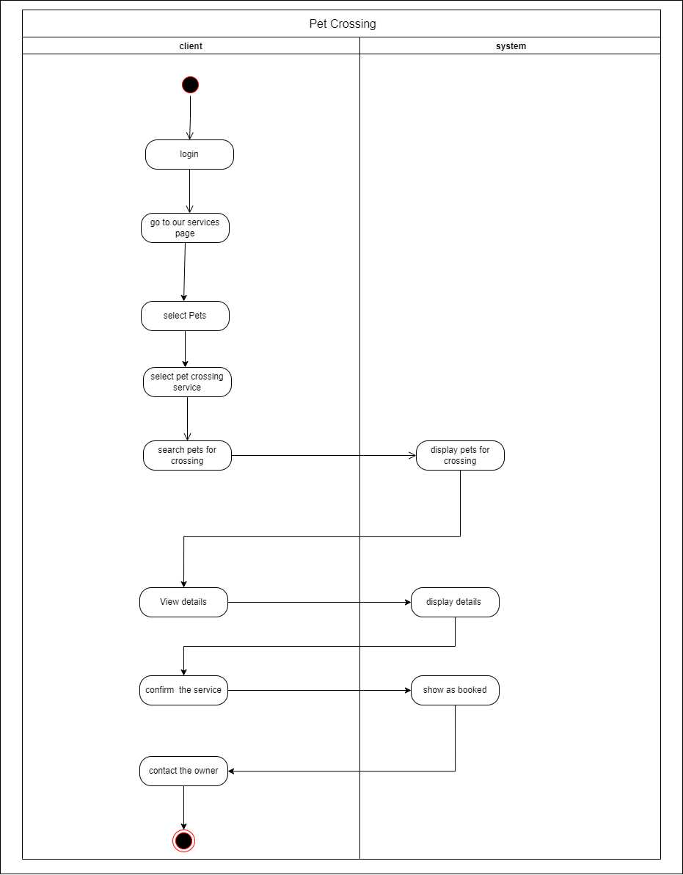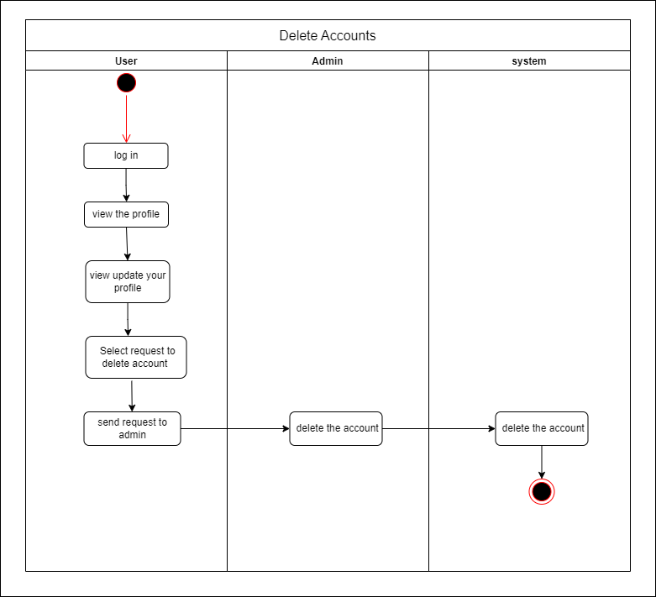

### 

# 

# Component Diagram

#### 

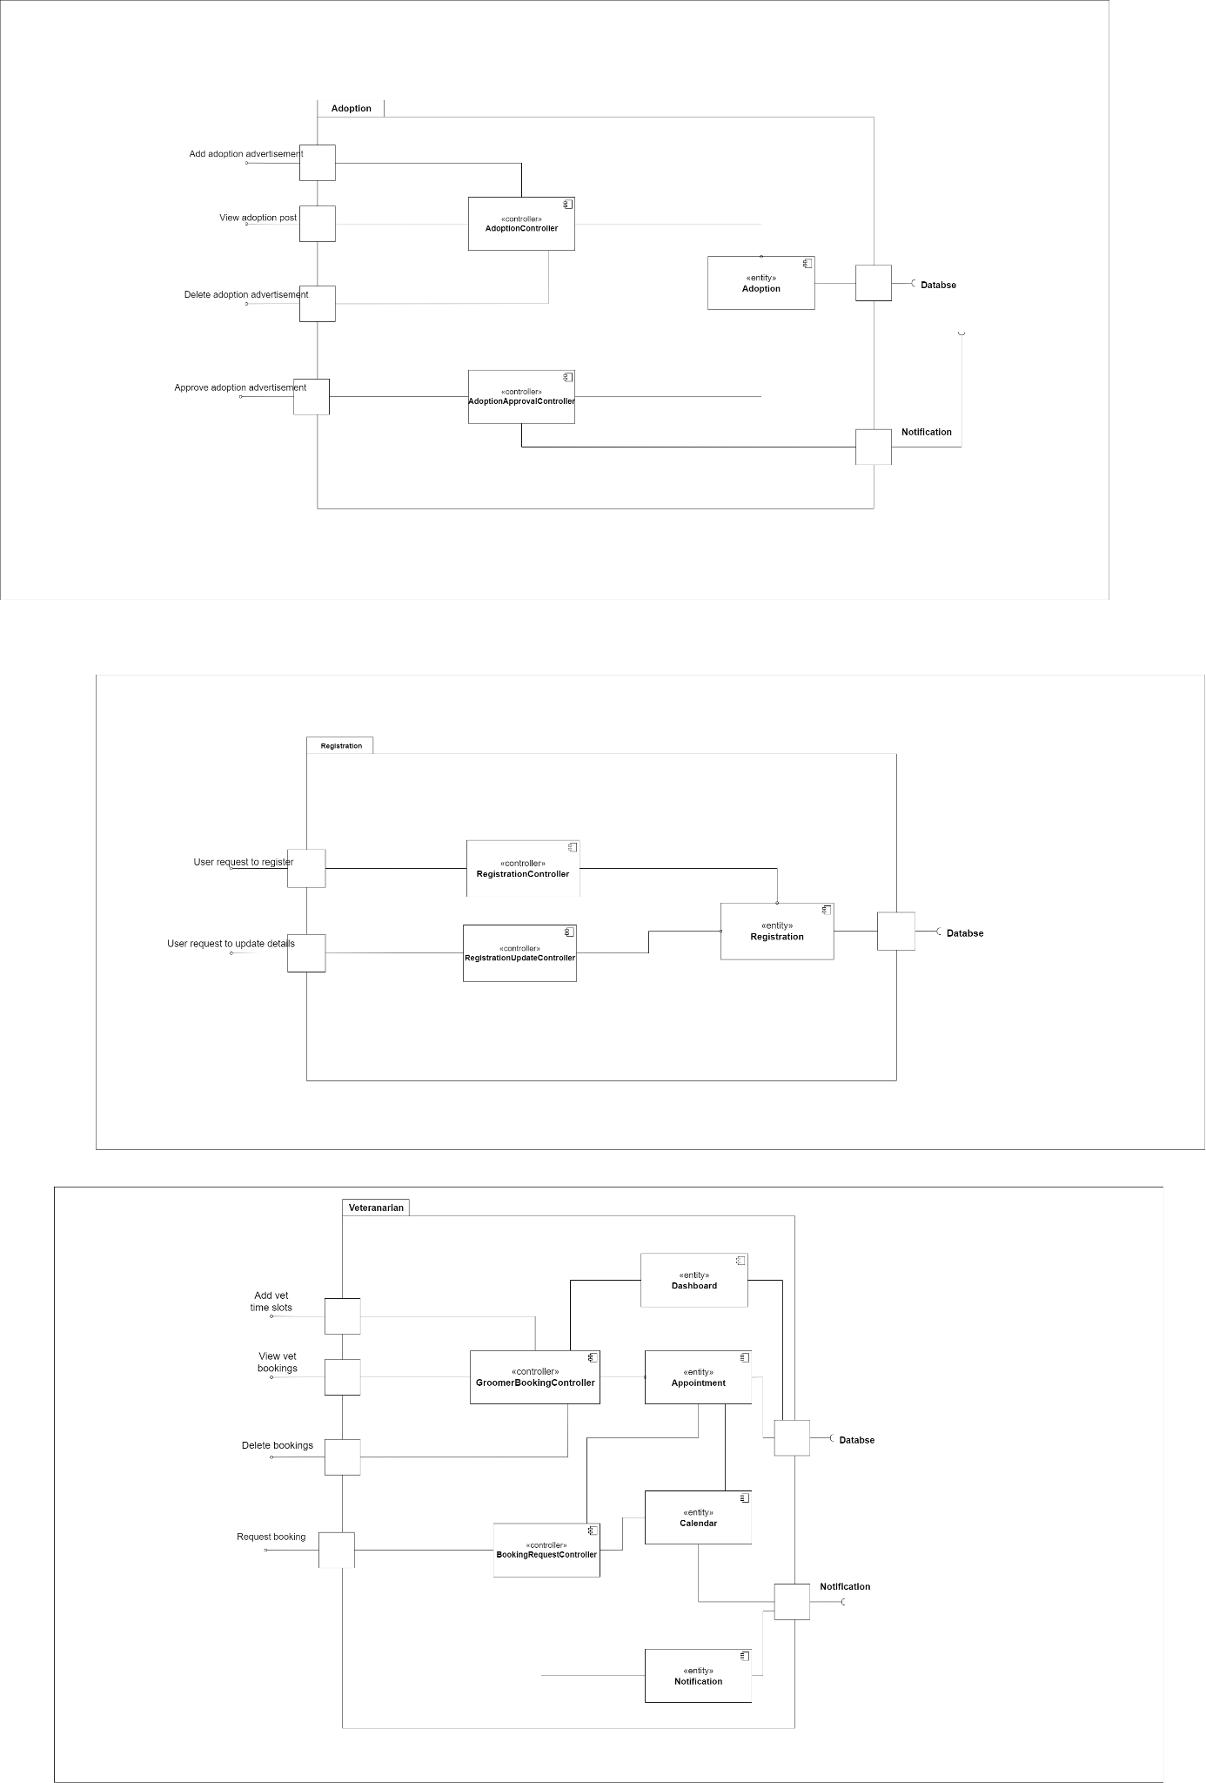





### Component Description

#### 

|  |  |
| --- | --- |
| Component | Functionality |
| Login | Allow users to access their accounts. Provide an interface to enter user credentials. |
| Authentication | Validate user details. |
| Appointment | Allows to book time slots. |
| Dashboard | Allows users to check the progress of actions |
| Notifications | Provide follow-up of appointments  Remind the upcoming events |
| Calendar | Shows all the appointments |
| Feedback | Provide the ability to complement and complain.  Provide reviews to service providers. |
| Payment Gateway | Accept and process payments.  Refund payments. |
| Registration | Allows new users to access the services. |

# High-Level Architecture

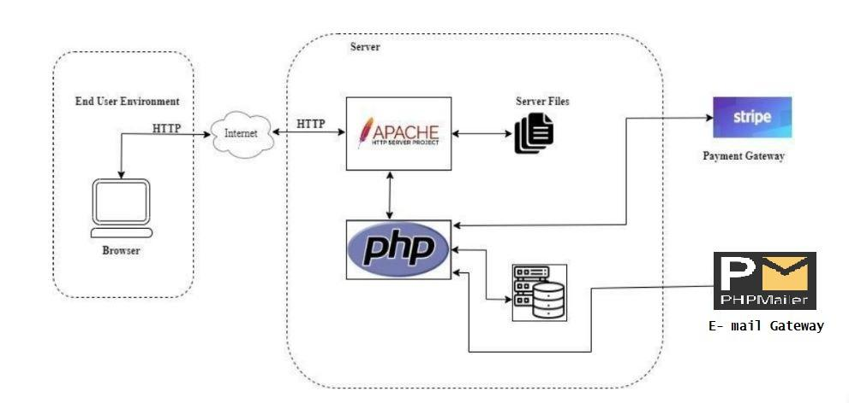

# Test cases

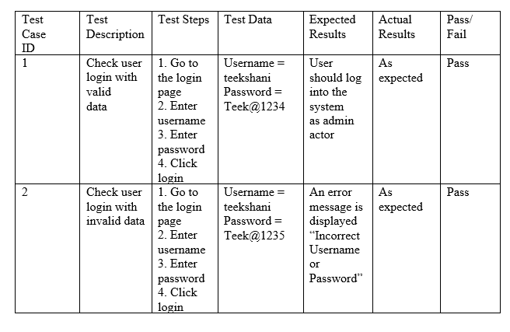

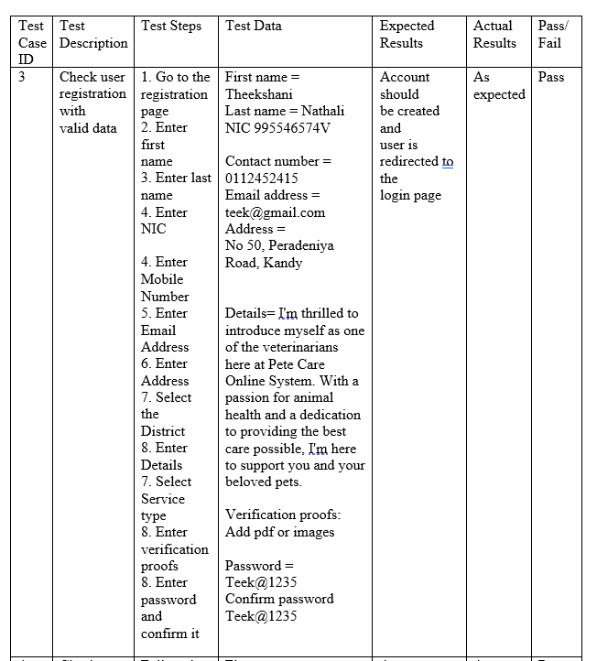

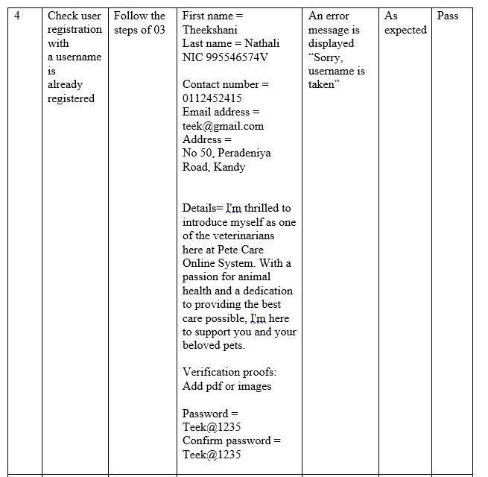

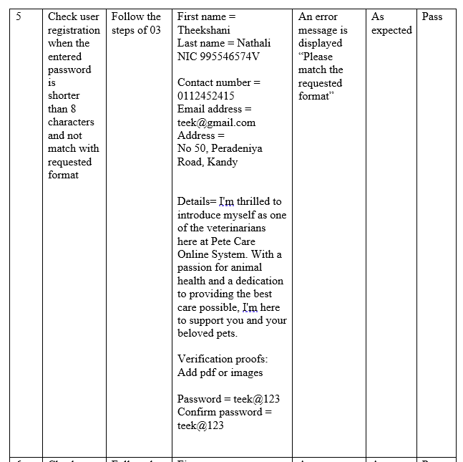

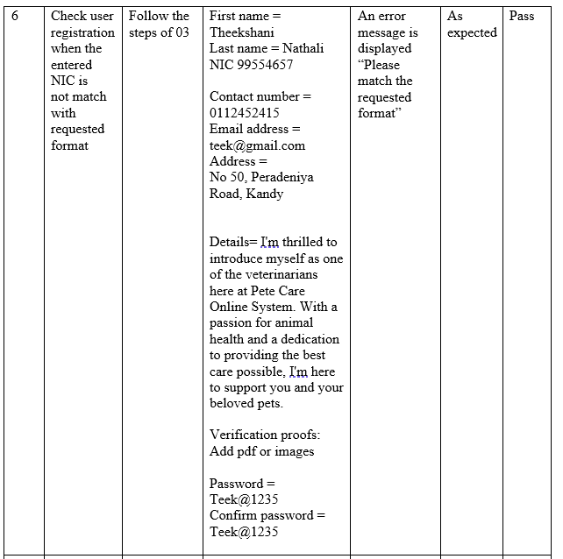

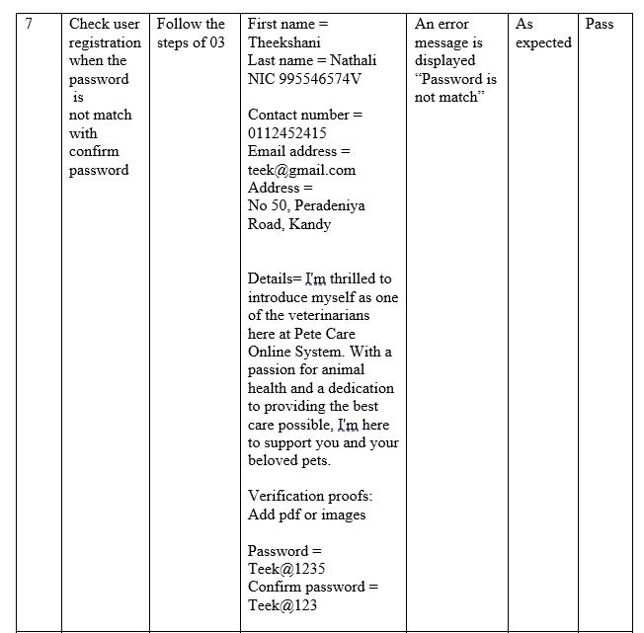

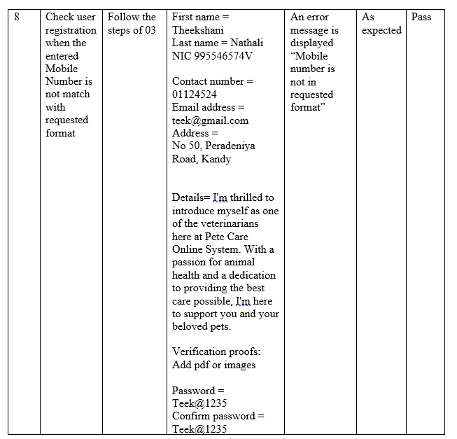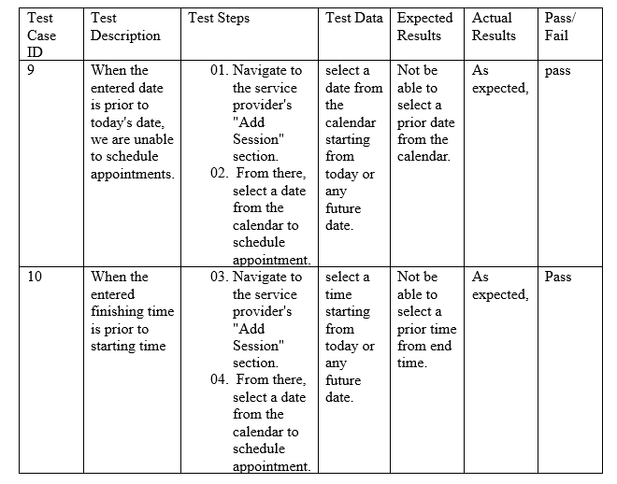

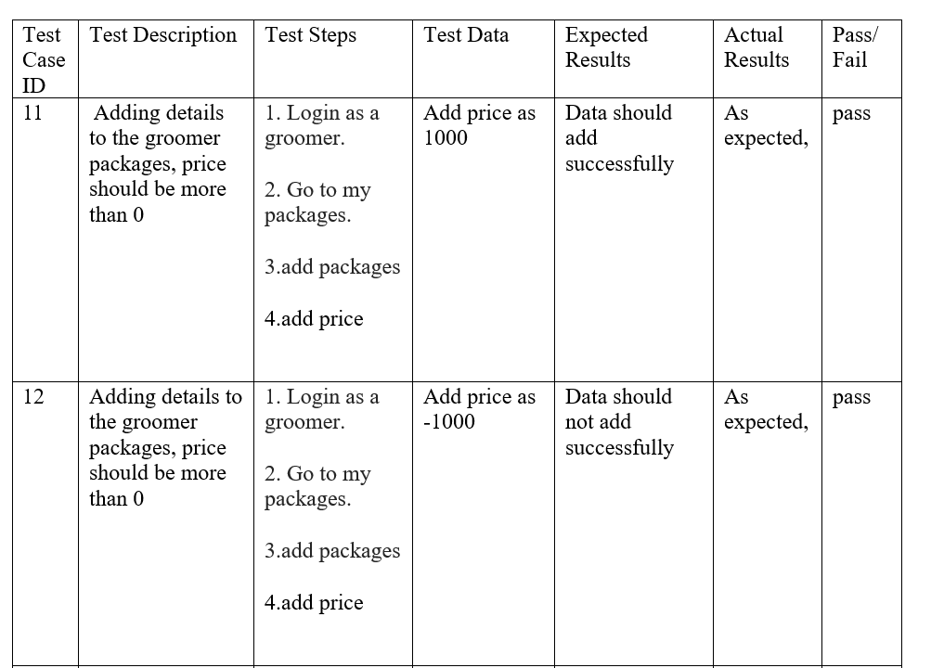

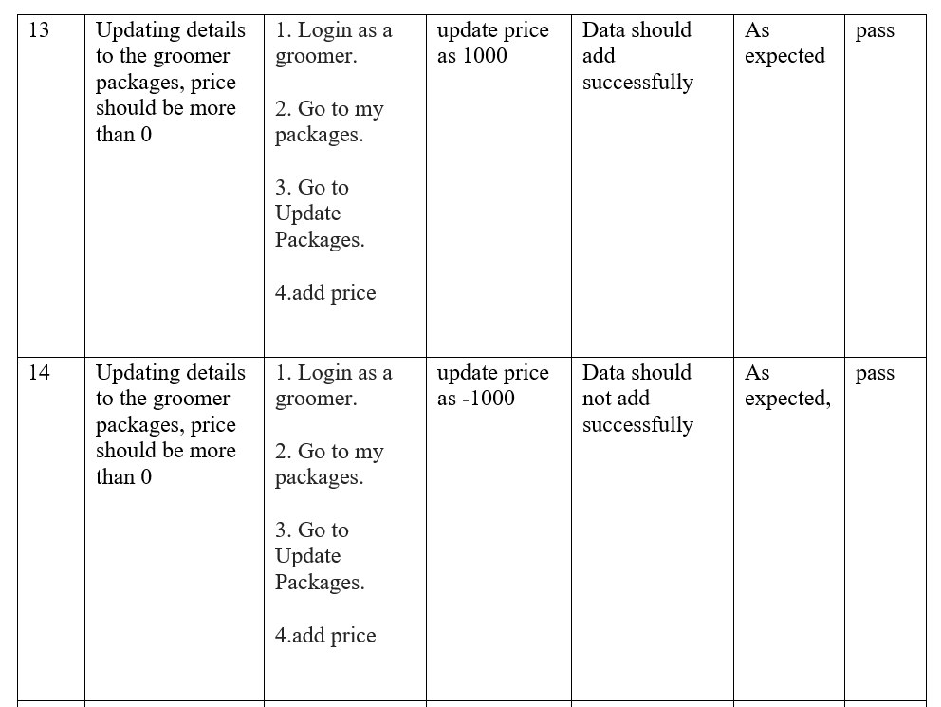

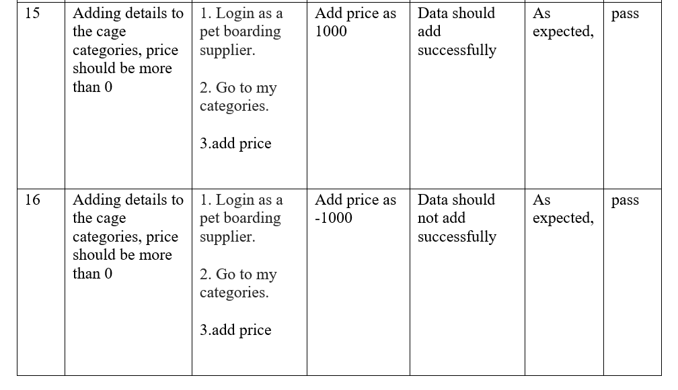

# Individual Contribution

Student ID - 20021161

Student Name – Wickramasinghe T.N.

Group ID – IS 06

Group Name - Pet Assure

Name of the component (s)

* Registration Page -Client /Service provider
* Pet Sitting service: adding available dates, cancel appointments, booking history .
* Pet Boarding service
* Database Creation
* Pet sitter Booking dates
* Pet sitter records
* View of clients details who get pet sitting service
* Service provider appointments -Adding appointments

Description of the component(s)

* Registration Page: Client/Service Provider If the client or service provider does not have an account, they can go to the registration form using the sign-in link. There are a few fields to add personal details, such as email and password, and to confirm the password. Then the service provider and client can register themselves.
* Pet Sitting Service: The pet sitter requests to view records regarding the pet sitting service that he supplied. Pet sitters are able to delete unnecessary records. Pet sitter can add available dates and cancel the appointments .
* Pet Boarding Service: A pet boarding service supplier allows to add cage categories and can add, update, delete the details regarding cages . Can view the details about clients and their pet details .
* Pet sitter booking dates: In here it will show the available dates of the pet sitters and client can book those details.
* Pet sitter records: In here it will show the past booking details about pet sitter.
* View of clients details who get pet sitting service
* Service provider appointments: grooming service suppliers and veterinarians can add time slots for appointments. Clients can view and book appointments. When an appointment is booked, the service provider gets a notification. If the service provider is not allowed to complete the appointment, the service provider is allowed to delete the appointment.

Student ID – 20020937

Student Name – M.S. Sangeerthan

Group ID – IS 06

Group Name - Pet Assure

Name of the component (s)

* Client user profile, update profile
* Client view of groomer profile
* Client view of Pet Boarding service supplier profile
* Client view of Veterinarian profile
* Add new pet sale, pet adoption, pet crossing post

Description of the component(s)

* Client user profile, update profile . Client who registered and logged in to the systems have their own user profiles. client can see their details in the user profile UI . client can edit their user details and profile images by using the Client Update Profile UI.
* Client view of groomer profile – client can view groomer details and images and book appointment by using this facility
* Client view of Pet Boarding service supplier profile - client can view pet boarding places details and images and book the cage by using this facility
* Client view of Veterinarian profile - client can view groomer details and images and book appointment by using this facility
* Add new pet sale, pet adoption, pet crossing posts – Clients can upload information and pictures regarding dogs they want to buy, sell, give away, or adopt.

Student ID: 20020589

Student Name: R. S. P. N. Krishnajina

Group ID: IS_06

Group Name: PetAssure

Name of the component (s):

* Admin dashboard
* Notification view
* View client, service providers details
* Payment gateway
* Update, edit of all Profile
* Description of the component(s):
* Admin dashboard: This component will display the client data overview and provide an idea to the admin about the performance of the system
* Notifications – When a signup, registrations happen it sends notifications and it is visible to the admin
* View details allows admin to view individual details of the registrants of the system
* Payment gateway allows clients to do the payments through their cards
* Update of all Profiles: Admin can update their profile including details such as name, last name, address. But they are restricted to change other confidential details such as password.

Student ID - 20020341

Student Name – Ishini Ekanayake

Group ID – IS 06

Group Name - Pet Assure

Name of the component (s)

* Login Page/Home Page
* Service provider - User Profile Page /Update Profile page
* Sending a notification about the request to delete the service provider account for admin
* Service provider dashboard
* Veterinarian: Consulted Pet Details Page
* Give and view ratings and feedback.
* Free consultation service (live chat)
* Grooming service provider: view package details, add packages, Grooming service provider update delete package details UI

Description of the component(s)

* Login Page/Home Page: From the home page system, users can redirect to the sign-up or sign-in pages. All the users can login to the system using their credentials. If the Users who don't have an account can go to the registration form using the sign-in link.
* Service provider User Profile: the service providers who registered and logged in to the systems have their own user profiles. Users can see their details in the user profile UI . Users can edit their user details and profile images by using the User Update Profile UI.
* Request to delete page : Sending a notification about the request to delete the service provider account for admin:.Service providers can send request to delete their account to admin from the request to delete UI.
* Service provider dashboard: Service providers can view their records easily and easily redirect their other UIs using this dashboard.
* Consulted Pet Details Page: A veterinarian can get records of consulted pets, such as pet name, pet type, pet breed, and pet owner details such as owner name and contact number. And if there are any remarks about the appointment, the veterinarian can add a note in this UI. and also veterinarians can delete unnecessary records on this page.
* Give and view ratings and feedback. -Give feedback messages and give ratings for veterinarians by client, and veterinarians can view their own ratings and feedbacks by these UIs.
* Free consultation service via live chat: the client can chat with the veterinarian and get free consultation service through the chat.
* Groomer packages: The client can view package details which added by grooming service supplier. can add, view ,update , delete package details.

Project Supervisor (Academic Staff of UCSC):

Name of the supervisor: Ms. JE Jayathma Chathurangani

Project Co-Supervisor (Assigned by Course Coordinator):

Name of the co-supervisor: Ms.Lakshika Gamage